**NEWSPORTAL**

*A*

*Project Report*

*Submitted in partial fulfilment of the*

*Requirements for the award of the Degree of*

**BACHELOR OF ENGINEERING**

IN

**INFORMATION TECHNOLOGY**

By

**Navaneeth Krishna Tanguturi (1602-19-737-138)**

**Saketh Varma Yarram Shetty (1602-19-737-161)**

**Satwik Kasukurthi (1602-19-737-165)**

*Under the guidance of*

**Mr. Dharma Reddy**

**Assistant Professor**



**Department of Information Technology**

**Vasavi College of Engineering (Autonomous)**

**(Affiliated to Osmania University) Ibrahim Bagh, Hyderabad-31**

**2021-2022**

**Vasavi College of Engineering (Autonomous)**

**(Affiliated to Osmania University)**

**Hyderabad-500031**

**Department of Information Technology**



**DECLARATION BY THE CANDIDATES**

We, **Navaneeth Krishna Tanguturi, Saketh Varma, Satwik Kasukurthi** bearing hall ticket number, **1602-19-737-138, 1602-19-737-161, 1602-19-737-165** hereby declare that the project report entitled **“NEWSPORTAL”** under the guidance of **Mr. Dharma Reddy** , Assistant Professor, Department of Information Technology, Vasavi College of Engineering, Hyderabad, is submitted in partial fulfilment of the requirement of MINI PROJECT of V semester of **Bachelor of Engineering** in **Information**  **Technology.**

This is a record of bonafide work carried out by us and the results embodied in this project report have not been submitted to any other university or institute for the award of any other degree or diploma.

**Navaneeth Krishna Tanguturi(1602-19-737-138)**

**Saketh Varma Yarram Shetty(1602-19-737-161)**  **Satwik Kasukurthi (1602-19-737-166**)

**Vasavi College of Engineering (Autonomous)**

**(Affiliated to Osmania University)**  **Hyderabad-500031**

**Department of Information Technology**



**BONAFIDE CERTIFICATE**

This is to certify that the project entitled “**NEWSPORTAL**” being submitted by **NAVANEETH KRISHNA TANGUTURI**, **SAKETH VARMA**, **SATWIK KASUKURTHI** bearing hall ticket numbers 1602-198-737-138, 1602-19-737-161, 1602-19-737-165 in partial fulfilment of the requirements for the completion of MINI PROJECT of Bachelor of Engineering in Information Technology is a record of bonafide work carried out by them under guidance.

**Mr. Dharma Reddy** **DR. K. Ram Mohan Rao**

**Assistant Professor** **HOD, IT**

**Internal Guide**

**ABSTRACT**

In this modern day, everyone expects to access anything they want within a touch of a button. A Portal is most often one specially designed web page which bring information together from diverse sources in a uniform way. News Portal is an online website of a web-based newspaper that allows the users to catch up on the latest news of various categories such as Politics, Sports, Films etc.

Contents

1) INTRODUCTION 1

1.1) What is a News Portal? 1

1.2) Why News Portal? 1

2) TECHNOLOGIES USED 2

2.1.1) FRONT-END 2

2.1.2) DATABASES 3

2.1.3 BACK-END 4

3) ANALYSIS OF THE PROJECT DEVELOPED 5

3.1 INTRODUCTION 5

3.2 USER STORY 6

ADMINISTRATOR: 7

4) DESIGN 8

4.1) UML DIAGRAMS 8

5) IMPLEMENTATION AND SCREENS 10

5.1.1 Home Page 10

5.1.2) Registration Page 12

5.1.3) Login Page 16

5.1.4) Contact Page 17

5.1.5) User’s Profile 22

5.1.6) Editing Profile Details 34

5.1.7) Add a New Post 35

5.1.8) View My Posts 37

5.1.9) Verified Users 39

5.1.10) Verified Articles 41

5.1.11) Non-Verified Users 44

5.1.12) Non-Verified Articles 46

5.1.13) Reading Live News 48

5.1.14) Read Live News 51

5.1.15) Read Full Post 53

5.1.16) Viewing All News 56

5.1.16.1) Viewing news of category ‘Politics’ 58

5.1.16.2) Viewing news of category ‘Business’ 60

5.1.16.3) Viewing news of category ‘Sports’ 61

5.1.16.4) Viewing news of category ‘Film’ 63

5.1.16.5) Viewing news of category ‘Tech’ 64

5.1.16.6) Viewing news of category ‘World’ 65

5.1.17) Header 65

5.1.18) Footer 66

5.2) Backend: Flask 69

5.2.1) app.py 69

5.2.2) Summarizer.py 90

5.2.3) SentimentAnalysis.py 92

5.2.4) Translator.py 92

5.2.5) WebScraper.py 92

5.3) Databases 92

5.3.1) ‘newspaperx’ database 92

5.3.1) ‘role’ table 93

5.3.1) ‘articles’ table 94

5.3.1) ‘userdetail’ table 94

6) FUTURE SCOPE 95

7) REFERENCES 96

# INTRODUCTION

# What is a News Portal?

A Portal is most often one specially designed web page which bring information together from diverse sources in a uniform way.

News Portal is an online website of a web-based newspaper that allows the users to catch up on the latest news of various categories such as Politics, Sports, Films etc.

# 

# Why News Portal?

The problem behind the manual system of newspaper is that it involves all the clerical work, which is a complicated job. In today’s fast life, it is difficult for the users to get news at their move.

Some of the reasons why News Portal helps include:

* News Portal will help people to get any news in the world at any time and place, as long as you have an internet connection. People can catch up on the latest news, in that order.
* All the news articles will be separated into different categories, thus reducing the time and effort of the user to search for a specific news.
* User friendly interface
* Older news can also be read, unlike in a newspaper which contains only the news of that particular day.

# TECHNOLOGIES USED

**2.1)** PROGRAMMING LANGUAGES

# 2.1.1) FRONT-END

**HTML**

* Hypertext Markup Language (HTML) is the standard [markup language](https://en.wikipedia.org/wiki/Markup_language) for creating [web pages](https://en.wikipedia.org/wiki/Web_page) and [web applications](https://en.wikipedia.org/wiki/Web_application). [HTML elements](https://en.wikipedia.org/wiki/HTML_element) are the building blocks of HTML pages.
* "Hypertext" refers to the hyperlinks that an HTML page may contain.  "Markup language" refers to the way tags are used to define the page layout and elements within the page.
* [HTML elements](https://en.wikipedia.org/wiki/HTML_element) are the building blocks of HTML pages. With HTML constructs, [images](https://en.wikipedia.org/wiki/HTML_element#Images_and_objects) and other objects such as [interactive forms](https://en.wikipedia.org/wiki/Fieldset) may be embedded into the rendered page.  HTML elements are delineated by *tags*, written using [angle brackets](https://en.wikipedia.org/wiki/Bracket#Angle_brackets).
* HTML can embed programs written in a [scripting language](https://en.wikipedia.org/wiki/Scripting_language) such as [JavaScript](https://en.wikipedia.org/wiki/JavaScript), which affects the behaviour and content of web pages. Inclusion of CSS defines the look and layout of content.

**CSS**

* Cascading Style Sheets (CSS) is a [style sheet language](https://en.wikipedia.org/wiki/Style_sheet_language) used for describing the [presentation](https://en.wikipedia.org/wiki/Presentation_semantics) of a document written in a [markup language](https://en.wikipedia.org/wiki/Markup_language) like [HTML](https://en.wikipedia.org/wiki/HTML).
* CSS is designed to enable the separation of presentation and content, including [layout](https://en.wikipedia.org/wiki/Page_layout), colours, and [fonts](https://en.wikipedia.org/wiki/Typeface). This separation can improve content [accessibility](https://en.wikipedia.org/wiki/Accessibility), provide more flexibility and control in the specification of presentation characteristics, enable multiple [web pages](https://en.wikipedia.org/wiki/Web_page) to share formatting by specifying the relevant CSS in a separate .css file, and reduce complexity and repetition in the structural content.
* Example: In the following example all <p> elements will be centre aligned, with a red text color:

p {  
    color: red;  
    text-align center;  
}

* In addition to HTML, other markup languages support the use of CSS, including [XHTML](https://en.wikipedia.org/wiki/XHTML), [plain XML](https://en.wikipedia.org/wiki/Plain_Old_XML), [SVG](https://en.wikipedia.org/wiki/Scalable_Vector_Graphics), and [XUL](https://en.wikipedia.org/wiki/XUL).

**BOOTSTRAP**

* Bootstrap is a [free and open-source](https://en.wikipedia.org/wiki/Free_and_open-source_software) front-end framework (library) for designing [websites](https://en.wikipedia.org/wiki/Website) and [web applications](https://en.wikipedia.org/wiki/Web_application). It contains [HTML](https://en.wikipedia.org/wiki/HTML)- and [CSS](https://en.wikipedia.org/wiki/CSS)-based design templates for [typography](https://en.wikipedia.org/wiki/Typography), forms, buttons, navigation and other interface components, as well as optional [JavaScript](https://en.wikipedia.org/wiki/JavaScript) extensions.
* Bootstrap supports [responsive web design](https://en.wikipedia.org/wiki/Responsive_Web_Design). This means the layout of web pages adjusts dynamically, taking into account the characteristics of the device used (desktop, tablet, mobile phone).
* Bootstrap 3 supports the latest versions of the [Google Chrome](https://en.wikipedia.org/wiki/Google_Chrome), [Firefox](https://en.wikipedia.org/wiki/Firefox), [Internet Explorer](https://en.wikipedia.org/wiki/Internet_Explorer), [Opera](https://en.wikipedia.org/wiki/Opera_(web_browser)), and [Safari](https://en.wikipedia.org/wiki/Safari_(web_browser)) (except on Windows).

## 2.1.2) DATABASES

**SQLite**

* **SQLite**is a freely available open-source Relational Database Management System (RDBMS) that uses Structured Query Language (**SQL**).
* **SQL** is the most popular language for adding, accessing and managing content in a database. It is most noted for its quick processing, proven reliability, ease, and flexibility of use.

## 2.1.3 BACK-END

**Flask**

* Flask is a popular Python web framework, meaning it is a third-party Python library used for developing web applications. Flask is a micro web framework written in Python. It is classified as a microframework because it does not require tools or libraries

# ANALYSIS OF THE PROJECT DEVELOPED

## 3.1 INTRODUCTION

The project titled ‘**NEWS PORTAL**’ is an online website of a web-based newspaper for posting, monitoring and controlling different kinds of news articles. This portal is designed by using HTML, CSS, Bootstrap & Flask technologies, and SQLite for handling databases. This website mainly focuses on the basic operations of creation/updating of account, login, user/article verification, posting/editing new news articles, viewing news articles, deletion of account, logout.

In my project, the users are divided into 3:

1. User, who has to register themselves in order to view news articles, update their profile.
2. Editor, who can post/update news articles and view them.
3. Administrator, who will manage and control the users and the news articles that are being posted.

My website is easy to use as it categorizes the news articles into different categories like Politics, Business, Sports, Film, Tech and World, so that the user can easily find and read the news they wish to.

# 3.2 USER STORY

**USER:**

1. Register as a new user and login.
2. Read the news articles by category
3. Politics
4. Business
5. Sports
6. Film
7. Tech
8. World
9. View/Edit profile (includes updating of user information and profile picture)
10. Look at the contact details of the newspaper agency
11. Logout

After registration, the user has to wait for the verification by the Administrator. Only after being verified, they can access the portal.

**EDITOR:**

1. Register and login
2. Read the news articles by category
3. Politics
4. Business
5. Sports
6. Film
7. Tech
8. World
9. Add an article
10. View my articles (includes the editing option to the already posted articles)
11. View/Edit profile (includes updating of user information and profile picture)
12. Look at the contact details of the newspaper agency
13. Logout

After registration, the user has to wait for the verification by the Administrator. Only after being verified, they access the portal. The Administrator has to change the role to ‘Editor’. Only then, they can perform the activities of the editor.

All the articles that have been posted by the editor will only be displayed on the timeline if the Administrator verifies them i.e., only verified news articles are displayed on the timeline.

# ADMINISTRATOR:

1. Login
2. Read the news articles by category
3. Politics
4. Business
5. Sports
6. Film
7. Tech
8. World
9. View the list of details of Verified Users (includes the blocking and changing the role options)
10. View the list of details of Non-Verified Users (includes verify and delete options)
11. View the list of details of Verified News Articles
12. View the list of details of Non-Verified News Articles
13. View/Edit the profile
14. Look at the contact details of newspaper agency
15. Logout

# DESIGN

# 4.1) UML DIAGRAMS

**Use Case Diagram:**

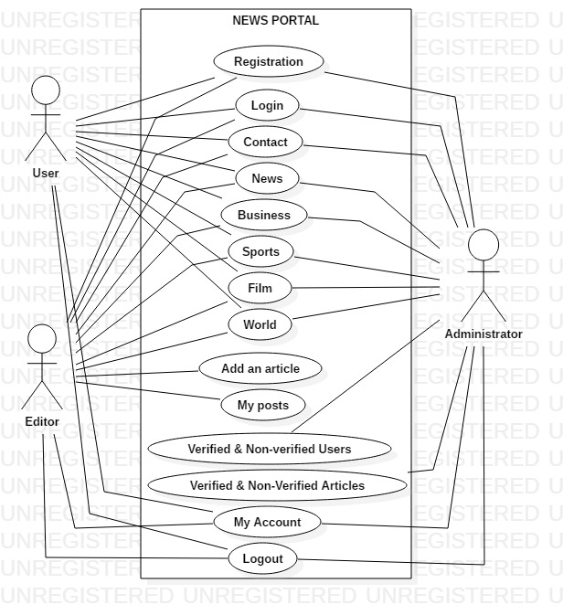

News Portal consists of 3 actors, User, Editor and Administrator.

**Activity Diagram**

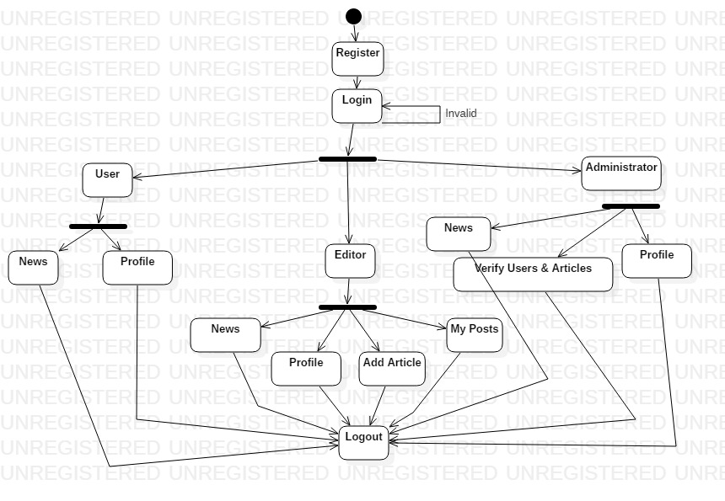

# IMPLEMENTATION AND SCREENS

# 5.1.1 Home Page

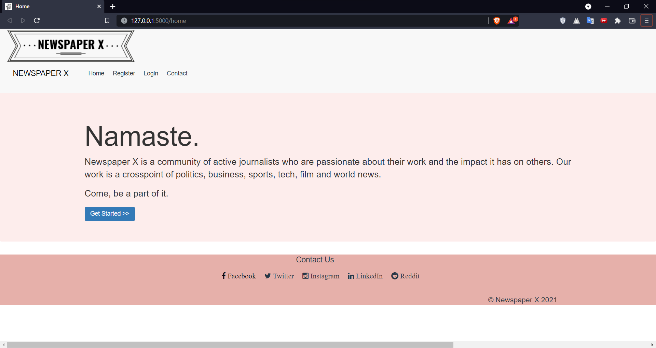

Code

<html>

<head>

    <title> Home </title>

    <link rel="shortcut icon" type = "image/x-icon" href = "{{url_for('static', filename='favicon.png')}}">

    <link href="{{url_for('static', filename='css/bootstrap.css')}}" rel="stylesheet" type="text/css">

    <link href="{{url_for('static', filename='css/bootstrap.min.css')}}" rel="stylesheet" type="text/css">

    <link href="{{url_for('static', filename='css/style2.css')}}" rel="stylesheet" type="text/css">

    <style>

        body{

            overflow-x: hidden;

        }

    </style>

</head>

{% include "header.html" %}

<body>

    <form action="/registration" method="POST">

        <div class="jumbotron vert-offset-top-3" style="background: #FDEDEC ; background-image:url(londonbg.png)">

            <div class="container">

                <div class="display-3">

                    <h1> Namaste. </h1>

                </div>

                <p> Newspaper X is a community of active journalists who are passionate about their work and the impact

                    it has on others. Our work is a crosspoint of politics, business, sports, tech, film and world news.

                </p>

                <p> Come, be a part of it. </p>

                <button type="submit" class="btn btn-primary display-2" name="login"> Get Started >> </button>

            </div>

        </div>

    </form>

</body>

{% include "footer.html" %}

</html>

# 5.1.2) Registration Page

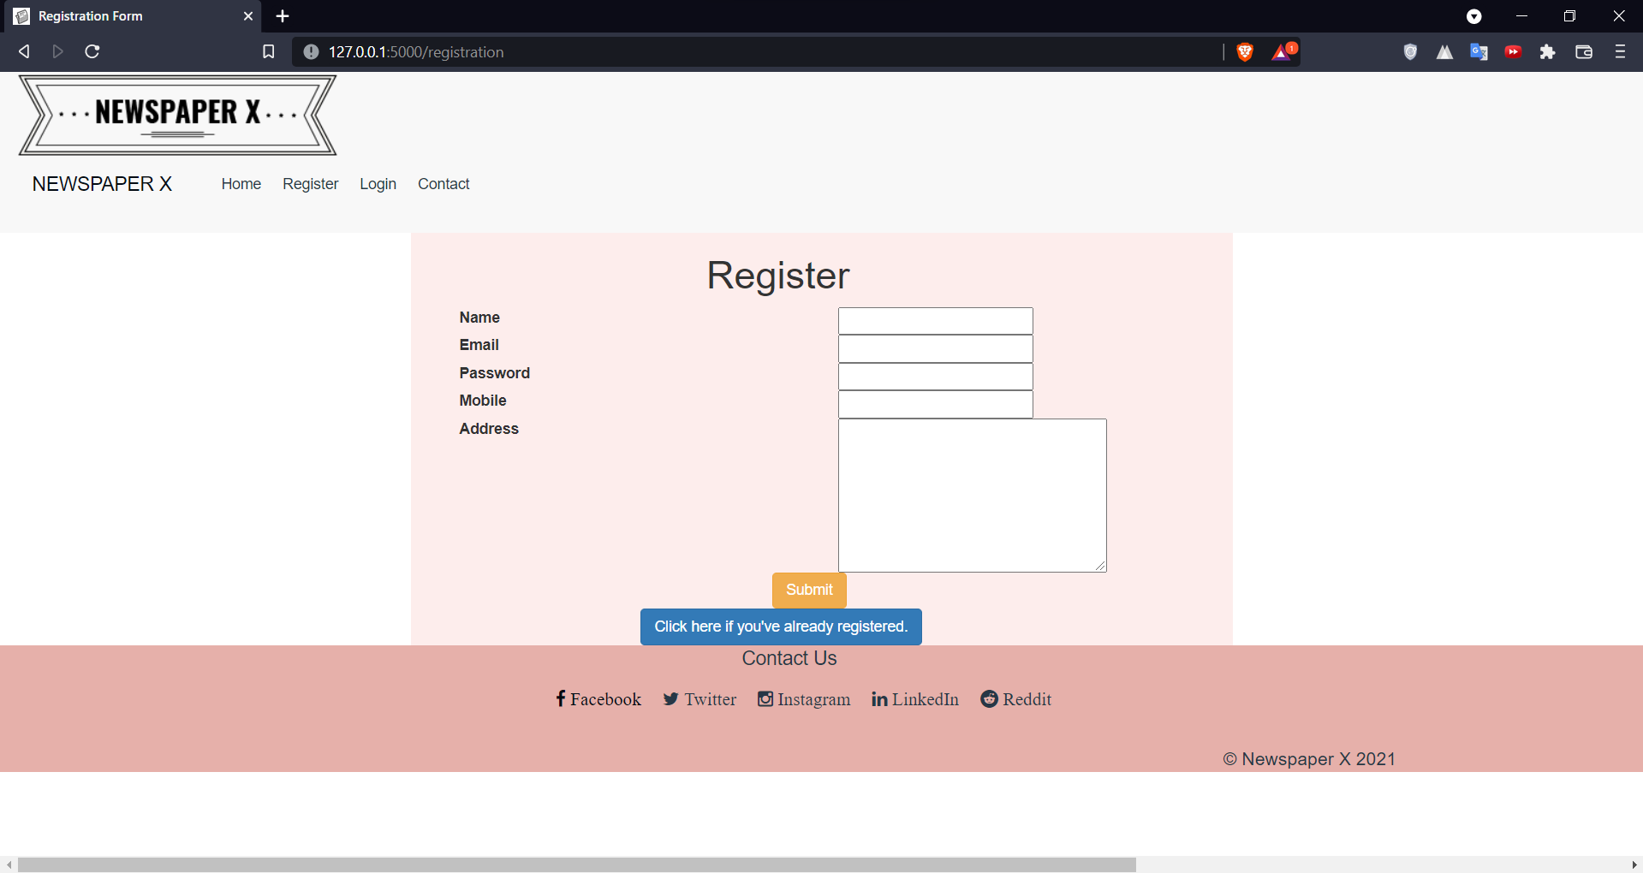

Code

<html>

<head>

    <title> Registration Form </title>

    <link rel="shortcut icon" type="image/x-icon" href="{{url_for('static', filename='favicon.png')}}">

    <link href="{{url_for('static', filename='css/bootstrap.css')}}" rel="stylesheet" type="text/css">

    <link href="{{url_for('static', filename='css/bootstrap.min.css')}}" rel="stylesheet" type="text/css">

    <link href="{{url_for('static', filename='css/style2.css')}}" rel="stylesheet" type="text/css">

    <link href="https://maxcdn.bootstrapcdn.com/font-awesome/4.4.0/css/font-awesome.min.css" rel="stylesheet" />

    <link href="https://maxcdn.bootstrapcdn.com/bootstrap/3.3.5/css/bootstrap.min.css" rel="stylesheet" />

    <script src="https://ajax.googleapis.com/ajax/libs/jquery/3.1.1/jquery.min.js"> </script>

    <script src="https://maxcdn.bootstrapcdn.com/bootstrap/3.3.7/js/bootstrap.min.js"> </script>

</head>

<body>

    {% include "header.html" %}

    <div class="col-md-6 col-md-offset-3 vert-offset-top-1" style="background: #FDEDEC">

        <form action="/register" method="POST">

            <div class="col-md-12 col-md-offset-4">

                <h1> Register </h1>

            </div>

            <span class="col-md-offset-4" style="color: red"> </span>

            <div class="col-md-12 vert-offset-top-1">

                <div class="col-md-6"> <label class="control-label"> Name </label> </div>

                <div class="col-md-6"> <input type="text" name="n"> </div>

            </div>

            <div class="col-md-12 vert-offset-top-1">

                <div class="col-md-6"> <label class="control-label"> Email </label> </div>

                <div class="col-md-6"> <input type="email" name="e"> </div>

            </div>

            <div class="col-md-12 vert-offset-top-1">

                <div class="col-md-6"> <label class="control-label"> Password </label> </div>

                <div class="col-md-6"> <input type="password" name="p"> </div>

            </div>

            <div class="col-md-12 vert-offset-top-1">

                <div class="col-md-6"> <label class="control-label"> Mobile </label> </div>

                <div class="col-md-6"> <input type="mobile" name="m"> </div>

            </div>

            <div class="col-md-12 vert-offset-top-1">

                <div class="col-md-6"> <label class="control-label"> Address </label> </div>

                <div class="col-md-6"> <textarea name="address" rows="7" cols="32"> </textarea></div>

            </div>

            <div class="col-md-7 col-md-offset-5 vert-offset-top-2"> <a href="{{ url_for('register') }}"> <button

                        type="submit" name="reg" class="btn btn-warning"> Submit </button> </a> </div>

            <div class="col-md-7 vert-offset-top-1 col-md-offset-3 "> <a href="{{ url_for('login') }}"> <button

                        type="button" class="btn btn-primary"> Click here if you've already registered. </button> </a>

            </div>

        </form>

    </div>

</body>

{% include "footer.html" %}

</html>

# 5.1.3) Login Page

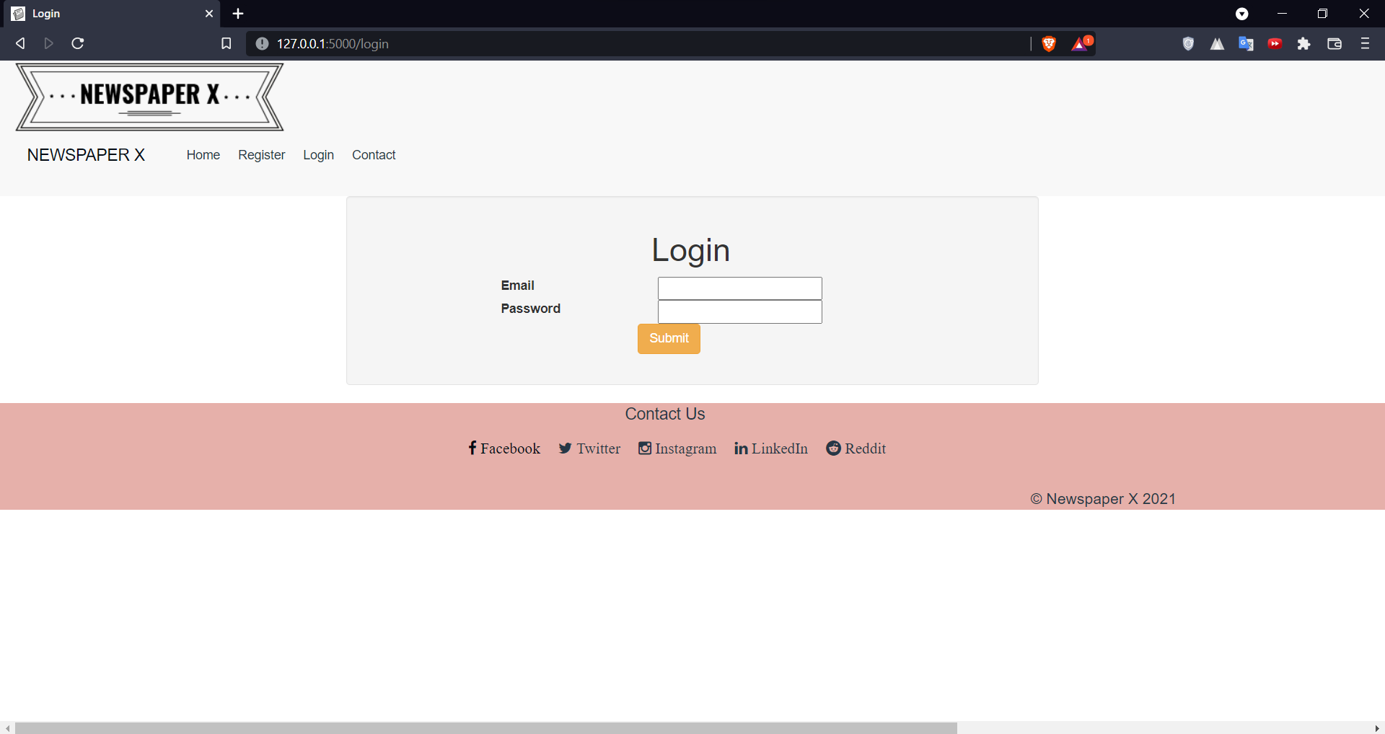

Code

<html>

  <head>

    <link rel="shortcut icon" type = "image/x-icon" href = "{{url_for('static', filename='favicon.png')}}">

    <title> Login </title>

    <link href="{{url_for('static', filename='css/bootstrap.css')}}" rel="stylesheet" type="text/css">

    <link href="{{url_for('static', filename='css/bootstrap.min.css')}}" rel="stylesheet" type="text/css">

    <link href="{{url_for('static', filename='css/style2.css')}}" rel="stylesheet" type="text/css">

  </head>

  <body>

    {% include "header.html" %}

    {% for mesg in get_flashed_messages() %}

        <p style="text-align: center; color: crimson;">{{mesg}}</p>

    {% endfor %}

    <div class = "well divbg col-md-6 col-md-offset-3 vert-offset-top-4">

        <form action="/authenticate" method = "POST">

        <div class = "col-md-12 col-md-offset-5"> <h1> Login </h1> </div>

        <div class = "col-md-12 vert-offset-top-2 col-md-offset-2">

          <div class = "col-md-3"> <label class = "control-label"> Email </label> </div>

          <div class = "col-md-4"> <input type = "email" name = "email"> </div>

        </div>

        <div class = "col-md-12 vert-offset-top-2 col-md-offset-2">

          <div class = "col-md-3"> <label class = "control-label"> Password </label> </div>

          <div class = "col-md-4"> <input type = "password" name = "password"> </div>

        </div>

        <div>

          <button class = "col-md-offset-5 vert-offset-top-2 btn btn-warning" type = "submit" name = "login"> Submit </button>

        </div>

       </div>

      </form>

  </body>

  {% include "footer.html" %}

</html>

# 5.1.4) Contact Page

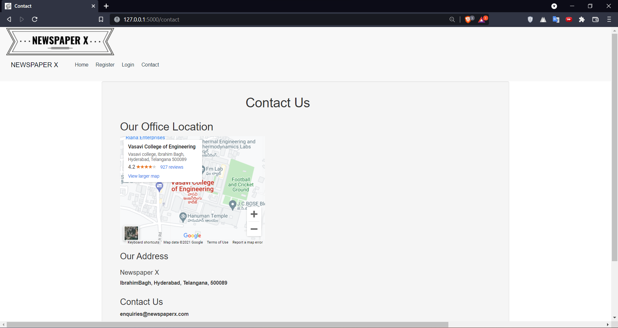

Code

<html>

<head>

    <title> Contact </title>

    <link rel="shortcut icon" type = "image/x-icon" href = "{{url_for('static', filename='favicon.png')}}">

    <link href="{{url_for('static', filename='css/bootstrap.css')}}" rel="stylesheet" type="text/css">

    <link href="{{url_for('static', filename='css/bootstrap.min.css')}}" rel="stylesheet" type="text/css">

    <link href="{{url_for('static', filename='css/style2.css')}}" rel="stylesheet" type="text/css">

    <style>

        body{

            overflow-x: hidden;

        }

    </style>

</head>

<body>

    {% if "admin" in user %}

    {% include "adminheader.html" %}

    {% elif "editor" in user %}

    {% include "editorheader.html" %}

    {% else %}

    {% include "userheader.html" %}

    {%endif%}

    <div class="well divbg col-md-8 col-md-offset-2 vert-offset-top-1">

        <form>

            <div class="col-md-12 col-md-offset-4">

                <h1> Contact Us </h1>

            </div>

            <div class="col-md-12 vert-offset-top-1">

                <div class="col-md-12">

                    <h2> Our Office Location </h2>

                </div>

                <div class="col-md-12"><iframe

                        src="https://www.google.com/maps/embed?pb=!1m18!1m12!1m3!1d1903.8254013314236!2d78.38151995803165!3d17.38052819702071!2m3!1f0!2f0!3f0!3m2!1i1024!2i768!4f13.1!3m3!1m2!1s0x3bcb942a2497f349%3A0x5c30ca8d2ffb8734!2sVasavi%20College%20of%20Engineering!5e0!3m2!1sen!2sin!4v1640431535233!5m2!1sen!2sin"

                        width="400" height="300" style="border:0;" allowfullscreen="" loading="lazy"></iframe></div>

                <br />

            </div>

            <div class="col-md-12 vert-offset-top-2">

                <div class="col-md-12">

                    <h3> Our Address </h3>

                </div>

                <div class="col-md-12">

                    <p>

                    <h4>Newspaper X </h4> <b>IbrahimBagh, Hyderabad, Telangana, 500089<b> </p>

                </div>

                <div class="col-md-12">

                    <h3> Contact Us </h3>

                </div>

                <div class="col-md-12">

                    <p> <b> enquiries@newspaperx.com <b> </p>

                    <p> <b> 040 2314 6098 </b> </p>

                </div>

            </div>

        </form>

    </div>

</body>

{% include "footer.html" %}

</html>

# 5.1.5) User’s Profile

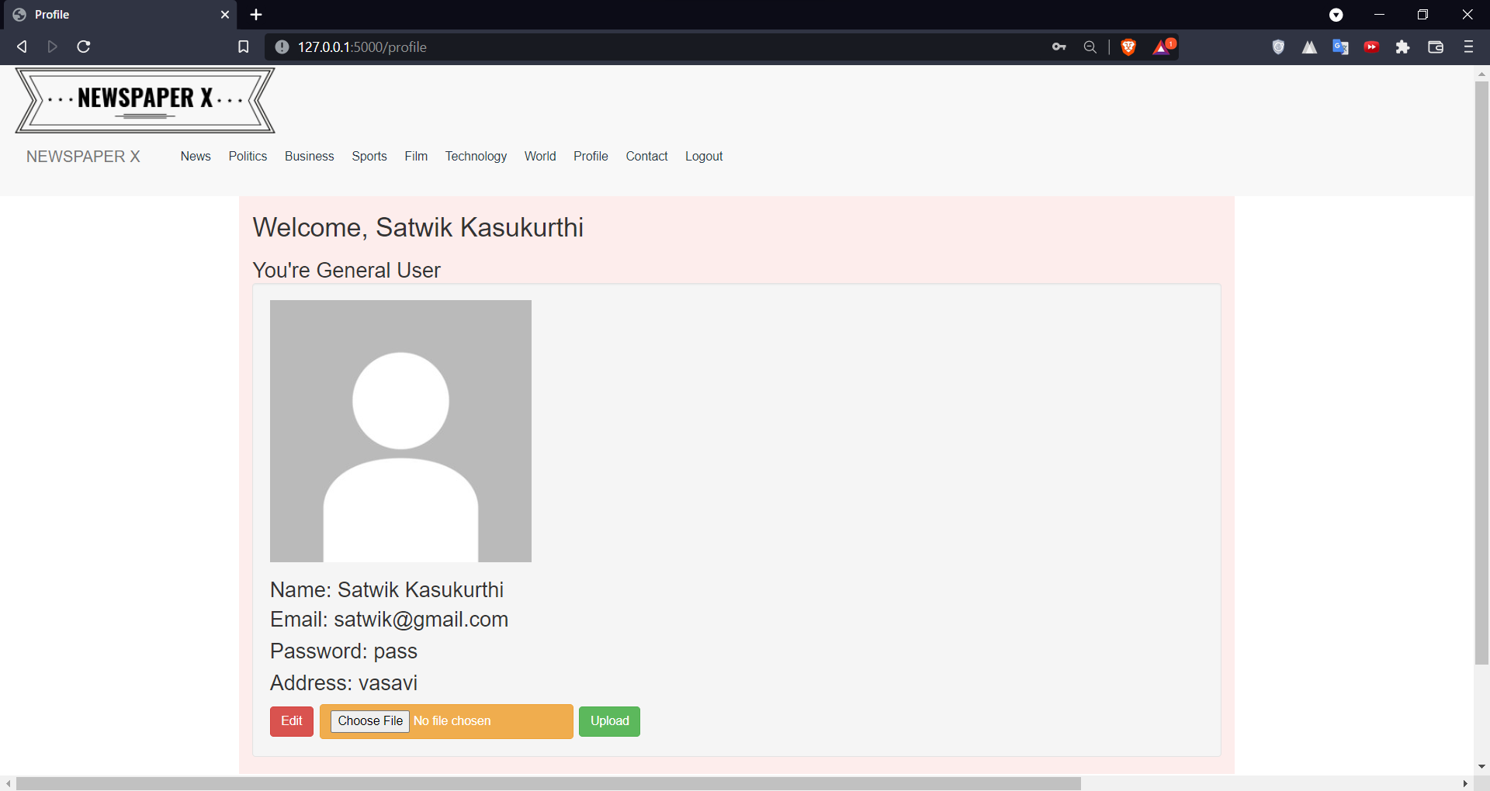

User Header

<html>

<head>

<title> Newspaper X </title>

<link href="{{url_for('static', filename='css/bootstrap.css')}}" rel="stylesheet" type="text/css">

<link href="{{url_for('static', filename='css/bootstrap.min.css')}}" rel="stylesheet" type="text/css">

<link href="{{url_for('static', filename='css/style2.css')}}" rel="stylesheet" type="text/css">

<link href="https://maxcdn.bootstrapcdn.com/font-awesome/4.4.0/css/font-awesome.min.css" rel="stylesheet" />

<link href="https://maxcdn.bootstrapcdn.com/bootstrap/3.3.5/css/bootstrap.min.css" rel="stylesheet" />

<script src="https://ajax.googleapis.com/ajax/libs/jquery/3.1.1/jquery.min.js"> </script>

<script src="https://maxcdn.bootstrapcdn.com/bootstrap/3.3.7/js/bootstrap.min.js"> </script>

</head>

<body>

<nav class="nav navbar-default foot">

<div class="col-md-12"> <img class="img-responsive" src="static/image/logo.png" alt="newspaper-x">

</div>

<div class="container-fluid">

<div class="nav-header">

<button type="button" class="navbar-toggle" data-toggle="collapse"

data-target="#NavBar">

<span class="icon-bar"> </span>

<span class="icon-bar"> </span>

<span class="icon-bar"> </span>

</button>

<a class="navbar-brand" href="#"> NEWSPAPER X </a>

</div>

<div class="collapse navbar-collapse" id="NavBar">

<ul class="navbar navbar-expand-xl">

<li class="nav-item" style="list-style-type: none;"> <a class="nav-link"

href="news" style="color: #273746"> News </a> </li>

<li class="nav-item" style="list-style-type: none;"> <a class="nav-link"

href="politics" style="color: #273746"> Politics </a> </li>

<li class="nav-item" style="list-style-type: none;"> <a class="nav-link"

href="business" style="color: #273746"> Business </a> </li>

<li class="nav-item" style="list-style-type: none;"> <a class="nav-link"

href="sports" style="color: #273746"> Sports </a> </li>

<li class="nav-item" style="list-style-type: none;"> <a class="nav-link"

href="film" style="color: #273746"> Film </a> </li>

<li class="nav-item" style="list-style-type: none;"> <a class="nav-link"

href="tech" style="color: #273746"> Technology </a> </li>

<li class="nav-item" style="list-style-type: none;"> <a class="nav-link"

href="world" style="color: #273746"> World </a> </li>

<li class="nav-item" style="list-style-type: none;"> <a class="nav-link"

href="profile" style="color: #273746"> Profile </a> </li>

<li class="nav-item" style="list-style-type: none;"> <a class="nav-link"

href="contact" style="color: #273746"> Contact </a> </li>

<li class="nav-item" style="list-style-type: none;"> <a class="nav-link"

href="logout" style="color: #273746"> Logout </a> </li>

</ul>

</div>

</nav>

</body>

</html>

Editor Header

<html>

<head>

        <title> Newspaper X </title>

        <link href="{{url_for('static', filename='css/bootstrap.css')}}" rel="stylesheet" type="text/css">

        <link href="{{url_for('static', filename='css/bootstrap.min.css')}}" rel="stylesheet" type="text/css">

        <link href="{{url_for('static', filename='css/style2.css')}}" rel="stylesheet" type="text/css">

        <link href="https://maxcdn.bootstrapcdn.com/font-awesome/4.4.0/css/font-awesome.min.css" rel="stylesheet" />

        <link href="https://maxcdn.bootstrapcdn.com/bootstrap/3.3.5/css/bootstrap.min.css" rel="stylesheet" />

        <script src="https://ajax.googleapis.com/ajax/libs/jquery/3.1.1/jquery.min.js"> </script>

        <script src="https://maxcdn.bootstrapcdn.com/bootstrap/3.3.7/js/bootstrap.min.js"> </script>

</head>

<body>

        <nav class="nav navbar-default foot">

                <div class="col-md-12"> <img class="img-responsive" src="static/image/logo.png" alt="newspaper-x">

                </div>

                <div class="container-fluid">

                        <div class="nav-header">

                                <button type="button" class="navbar-toggle" data-toggle="collapse"

                                        data-target="#NavBar">

                                        <span class="icon-bar"> </span>

                                        <span class="icon-bar"> </span>

                                        <span class="icon-bar"> </span>

                                </button>

                                <a class="navbar-brand" href="#"> NEWSPAPER X </a>

                        </div>

                        <div class="collapse navbar-collapse" id="NavBar">

                                <ul class="navbar navbar-expand-xl">

                                        <li class="nav-item" style="list-style-type: none;"> <a class="nav-link"

                                                        href="news" style="color: #273746"> News </a> </li>

                                        <li class="nav-item" style="list-style-type: none;"> <a class="nav-link"

                                                        href="politics" style="color: #273746"> Politics </a> </li>

                                        <li class="nav-item" style="list-style-type: none;"> <a class="nav-link"

                                                        href="business" style="color: #273746"> Business </a> </li>

                                        <li class="nav-item" style="list-style-type: none;"> <a class="nav-link"

                                                        href="sports" style="color: #273746"> Sports </a> </li>

                                        <li class="nav-item" style="list-style-type: none;"> <a class="nav-link"

                                                        href="film" style="color: #273746"> Film </a> </li>

                                        <li class="nav-item" style="list-style-type: none;"> <a class="nav-link"

                                                        href="tech" style="color: #273746"> Technology </a> </li>

                                        <li class="nav-item" style="list-style-type: none;"> <a class="nav-link"

                                                        href="world" style="color: #273746"> World </a> </li>

                                        <li class="nav-item" style="list-style-type: none;"> <a class="nav-link"

                                                        href="profile" style="color: #273746"> Profile </a> </li>

                                        <li class="nav-item" style="list-style-type: none;"> <a class="nav-link"

                                                        href="newpost" style="color: #273746"> New Post </a> </li>

                                        <li class="nav-item" style="list-style-type: none;"> <a class="nav-link"

                                                        href="viewposts" style="color: #273746"> View My Posts </a> </li>

                                        <li class="nav-item" style="list-style-type: none;"> <a class="nav-link"

                                                        href="contact" style="color: #273746"> Contact </a> </li>

                                        <li class="nav-item" style="list-style-type: none;"> <a class="nav-link"

                                                        href="logout" style="color: #273746"> Logout </a> </li>

                                </ul>

                        </div>

        </nav>

</body>

</html>

Admin Header

<html>

<head>

        <title> Newspaper X </title>

        <link rel="shortcut icon" type="image/x-icon" href="{{url_for('static', filename='favicon.png')}}">

        <link href="{{url_for('static', filename='css/bootstrap.css')}}" rel="stylesheet" type="text/css">

        <link href="{{url_for('static', filename='css/bootstrap.min.css')}}" rel="stylesheet" type="text/css">

        <link href="{{url_for('static', filename='css/style2.css')}}" rel="stylesheet" type="text/css">

        <link href="https://maxcdn.bootstrapcdn.com/font-awesome/4.4.0/css/font-awesome.min.css" rel="stylesheet" />

        <link href="https://maxcdn.bootstrapcdn.com/bootstrap/3.3.5/css/bootstrap.min.css" rel="stylesheet" />

        <script src="https://ajax.googleapis.com/ajax/libs/jquery/3.1.1/jquery.min.js"> </script>

        <script src="https://maxcdn.bootstrapcdn.com/bootstrap/3.3.7/js/bootstrap.min.js"> </script>

</head>

<body>

        <nav class="nav navbar-default foot">

                <div class="col-md-12"> <img class="img-responsive" src="static/image/logo.png" alt="newspaper-x">

                        <div class="container-fluid">

                                <div class="nav-header">

                                        <button type="button" class="navbar-toggle" data-toggle="collapse"

                                                data-target="#NavBar">

                                                <span class="icon-bar"> </span>

                                                <span class="icon-bar"> </span>

                                                <span class="icon-bar"> </span>

                                        </button>

                                        <a class="navbar-brand" href="#" style="color: #273746"> NEWSPAPER X </a>

                                </div>

                                <div class="collapse navbar-collapse" id="NavBar">

                                        <ul class="navbar navbar-expand-xl">

                                                <li class="nav-item" style="list-style-type: none;"> <a class="nav-link"

                                                                href="news" style="color: #273746"> News </a> </li>

                                                <li class="nav-item" style="list-style-type: none;"> <a class="nav-link"

                                                                href="politics" style="color: #273746"> Politics </a>

                                                </li>

                                                <li class="nav-item" style="list-style-type: none;"> <a class="nav-link"

                                                                href="business" style="color: #273746"> Business </a>

                                                </li>

                                                <li class="nav-item" style="list-style-type: none;"> <a class="nav-link"

                                                                href="sports" style="color: #273746"> Sports </a> </li>

                                                <li class="nav-item" style="list-style-type: none;"> <a class="nav-link"

                                                                href="film" style="color: #273746"> Film </a> </li>

                                                <li class="nav-item" style="list-style-type: none;"> <a class="nav-link"

                                                                href="tech" style="color: #273746"> Technology </a>

                                                </li>

                                                <li class="nav-item" style="list-style-type: none;"> <a class="nav-link"

                                                                href="world" style="color: #273746"> World </a> </li>

                                                <li class="nav-item" style="list-style-type: none;"> <a class="nav-link"

                                                                href="profile" style="color: #273746"> Profile </a>

                                                </li>

                                                <li class="nav-item" style="list-style-type: none;"> <a class="nav-link"

                                                                href="verifiedUsers" style="color: #273746"> Verified

                                                                Users </a> </li>

                                                <li class="nav-item" style="list-style-type: none;"> <a class="nav-link"

                                                                href="non-verifiedUsers" style="color: #273746">

                                                                Non-Verified Users </a> </li>

                                                <li class="nav-item" style="list-style-type: none;"> <a class="nav-link"

                                                                href="verifiedArticles" style="color: #273746"> Verfied Articles </a>

                                                </li>

                                                <li class="nav-item" style="list-style-type: none;"> <a class="nav-link"

                                                                href="non-verifiedArticles" style="color: #273746"> Non-Verfied Articles </a> </li>

                                                <li class="nav-item" style="list-style-type: none;"> <a class="nav-link"

                                                                href="contact" style="color: #273746"> Contact </a>

                                                </li>

                                                <li class="nav-item" style="list-style-type: none;"> <a class="nav-link"

                                                                href="logout" style="color: #273746"> Logout </a> </li>

                                        </ul>

                                </div>

                        </div>

        </nav>

</body>

</html>

Profile

<html>

<head>

    <title>Profile</title>

    <link href="{{url_for('static', filename='css/bootstrap.css')}}" rel="stylesheet" type="text/css">

    <link href="{{url_for('static', filename='css/bootstrap.min.css')}}" rel="stylesheet" type="text/css">

    <link href="{{url_for('static', filename='css/style2.css')}}" rel="stylesheet" type="text/css">

    <link href="https://maxcdn.bootstrapcdn.com/font-awesome/4.4.0/css/font-awesome.min.css" rel="stylesheet" />

    <link href="https://maxcdn.bootstrapcdn.com/bootstrap/3.3.5/css/bootstrap.min.css" rel="stylesheet" />

    <script src="https://ajax.googleapis.com/ajax/libs/jquery/3.1.1/jquery.min.js"> </script>

    <script src="https://maxcdn.bootstrapcdn.com/bootstrap/3.3.7/js/bootstrap.min.js"> </script>

    <style>

        body{

            overflow-x: hidden;

        }

    </style>

</head>

<body>

    {% if "admin" in user %}

        {% include "adminheader.html" %}

    {% elif "editor" in user %}

        {% include "editorheader.html" %}

    {% else %}

        {% include "userheader.html" %}

    {%endif%}

    {% for mesg in get_flashed_messages() %}

        <p style="text-align: center; color: crimson;">{{mesg}}</p>

    {% endfor %}

    <form action="/profile" method="POST" enctype="multipart/form-data">

        <div class="container vert-offset-top-1 divbg">

            <h2> Welcome, {{name}} </h2>

            <h3> You're {{role}}

                <div class="well">

                    <img height="300px" width="300px" src="{{image}}" alt="{{name}}">

                    <h3 class="card-title"> Name: {{name}} </h3>

                    <p class="card-text"> Email: {{email}}</p>

                    <p class="card-text"> Password: {{password}}</p>

                    <p class="card-text"> Address: {{address}} </p>

                    <button type="submit" class="btn btn-danger" name="edit" value = "edit"> Edit </button>

                    <button type="submit" class="btn btn-warning"> <input type="file" name="image" value = "image"> </button>

                    <button type="submit" class="btn btn-success" name="upload" value = "upload"> Upload </button>

                </div>

        </div>

    </form>

</body>

{% include "footer.html" %}

</html>

# 5.1.6) Editing Profile Details

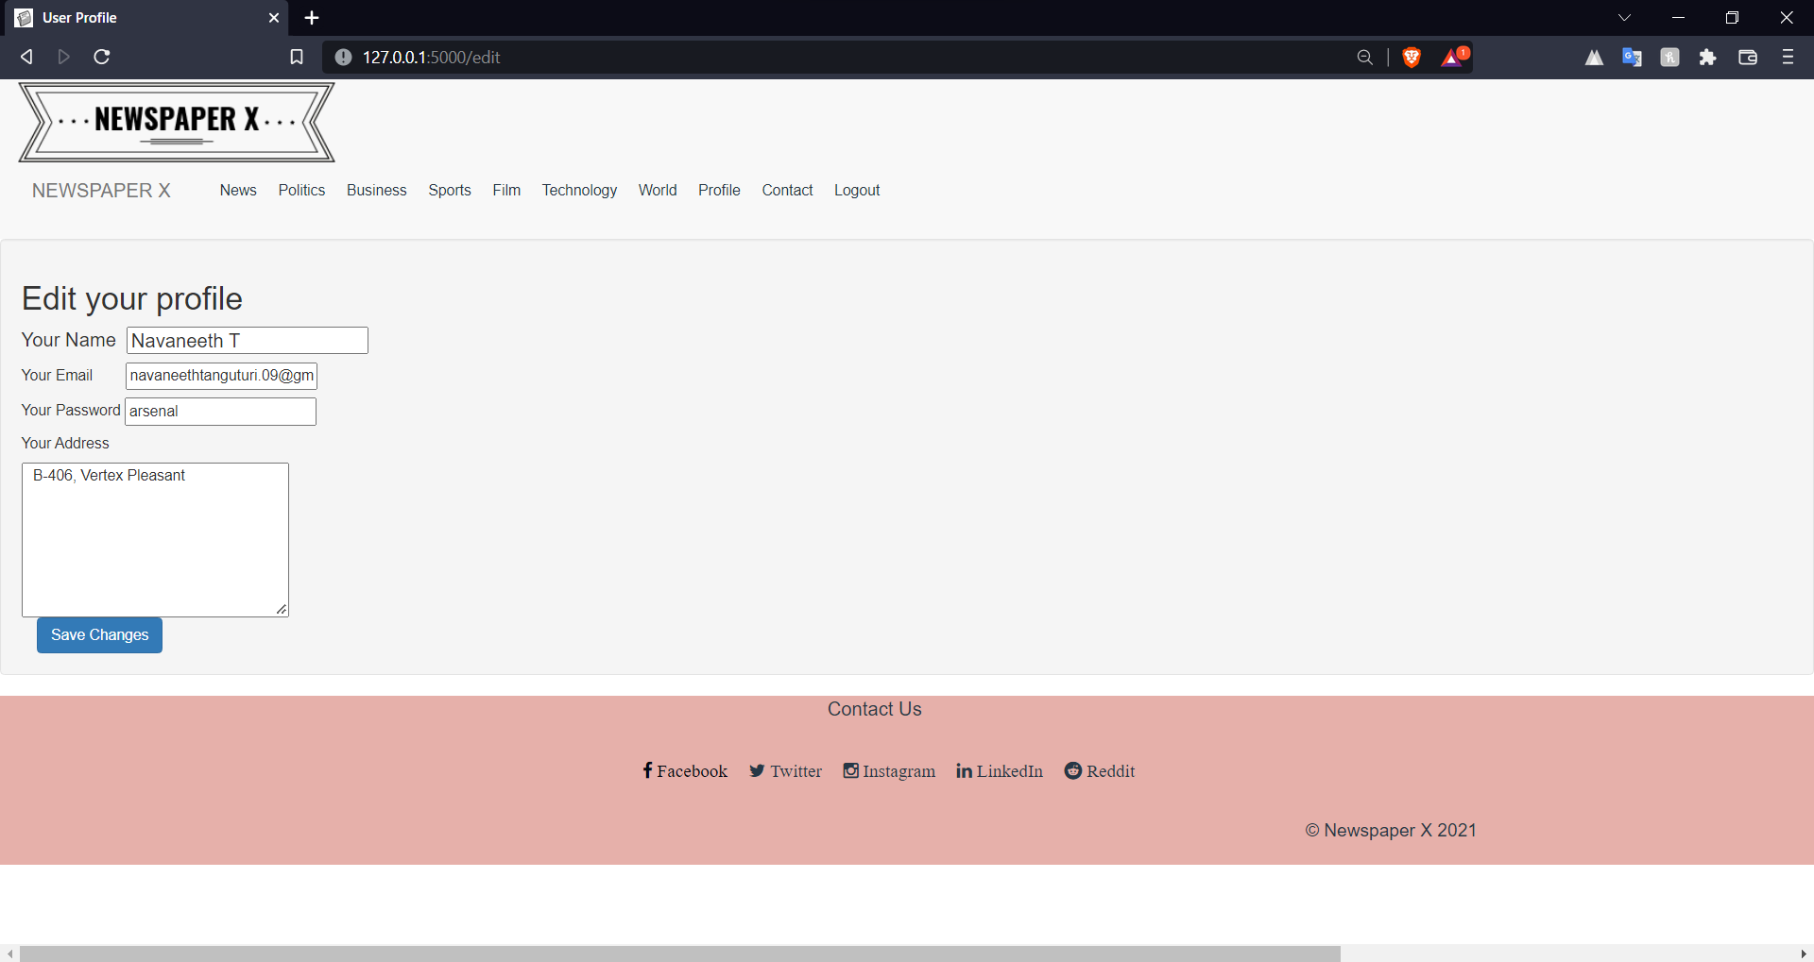

<html>

<head>

<title>User Profile</title>

<link rel="shortcut icon" type="image/x-icon" href="{{url_for('static', filename='favicon.png')}}">

<link href="{{url_for('static', filename='css/bootstrap.css')}}" rel="stylesheet" type="text/css">

<link href="{{url_for('static', filename='css/bootstrap.min.css')}}" rel="stylesheet" type="text/css">

<link href="{{url_for('static', filename='css/style2.css')}}" rel="stylesheet" type="text/css">

<link href="https://maxcdn.bootstrapcdn.com/font-awesome/4.4.0/css/font-awesome.min.css" rel="stylesheet" />

<link href="https://maxcdn.bootstrapcdn.com/bootstrap/3.3.5/css/bootstrap.min.css" rel="stylesheet" />

<script src="https://ajax.googleapis.com/ajax/libs/jquery/3.1.1/jquery.min.js"> </script>

<script src="https://maxcdn.bootstrapcdn.com/bootstrap/3.3.7/js/bootstrap.min.js"> </script>

</head>

<body>

{% if "admin" in user %}

{% include "adminheader.html" %}

{% elif "editor" in user %}

{% include "editorheader.html" %}

{% else %}

{% include "userheader.html" %}

{%endif%}

<form action="/edit" method="POST">

<div class="well divbg col-md-12 vert-offset-top-1">

<h2> Edit your profile</h2>

<div>

<h4 class="card-title"> Your Name&nbsp;&nbsp;<input type="text" value="{{name}}" name="n"> </h4>

<p class="card-title"> Your Email&nbsp;&nbsp;&nbsp;&nbsp;&nbsp;&nbsp;&nbsp;&nbsp;<input type="email"

value="{{email}}" name="e"> </p>

<p class="card-title"> Your Password&nbsp;<input type="text" value="{{password}}" name="p"> </p>

<p class="card-title"> Your Address&nbsp;</p>

<textarea name="a" rows="7" cols="32"> {{address}} </textarea>

<div class="col-md-12 vert-offset-top-1"> <button type="submit" class="btn btn-primary" name="update">

Save Changes </button> </div>

</div>

</div>

</form>

</body>

{% include "footer.html" %}

</html>

# 5.1.7) Add a New Post

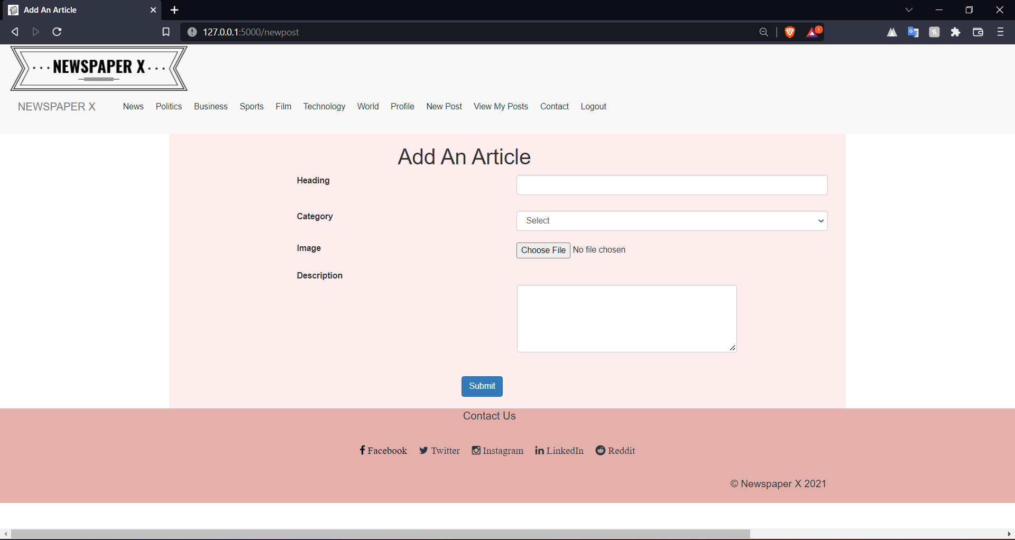

<html>

<head>

    <title> Add An Article </title>

    <link rel="shortcut icon" type="image/x-icon" href="{{url_for('static', filename='favicon.png')}}">

    <link href="{{url_for('static', filename='css/bootstrap.css')}}" rel="stylesheet" type="text/css">

    <link href="{{url_for('static', filename='css/bootstrap.min.css')}}" rel="stylesheet" type="text/css">

    <link href="{{url_for('static', filename='css/style2.css')}}" rel="stylesheet" type="text/css">

    <style>

        #matter {

            margin-left: 570px;

        }

    </style>

</head>

<body>

    {% include "editorheader.html" %}

    {% for mesg in get_flashed_messages() %}

        <p style="text-align: center; color: crimson;">{{mesg}}</p>

    {% endfor %}

    <form action="/addnewpost" method="POST" enctype="multipart/form-data">

        <div class="container divbg col-md-8 col-md-offset-2 vert-offset-top-1">

            <div class="col-sm-offset-4">

                <h1> Add An Article </h1>

            </div>

            <div class="col-sm-4 col-sm-offset-2 vert-offset-top-2"> <label class="control-label"> Heading </label>

            </div>

            <div class="col-sm-6 vert-offset-top-2"> <input type="text" class="form-control" name="head"> </div><br><br><br>

            <div class="col-sm-4 col-sm-offset-2 vert-offset-top-1"> <label class="control-label"> Category </label>

            </div>

            <div class="col-sm-6 vert-offset-top-1">

                <select class="form-control" name="cat">

                    <option> Select </option>

                    <option> Politics </option>

                    <option> Business </option>

                    <option> Sports </option>

                    <option> Film </option>

                    <option> Tech </option>

                    <option> World </option>

                </select><br>

            </div>

            <div class="col-sm-4 col-sm-offset-2 vert-offset-top-2"> <label class="control-label"> Image </label> </div>

            <div class="col-sm-6 vert-offset-top-2"> <input type="file" name="image"><br> </div>

            <div class="col-sm-12 col-sm-offset-2  vert-offset-top-2"> <label class="control-label"> Description

                </label> </div>

            <textarea class="col-sm-4  vert-offset-top-1 form-control" rows="5" name="descri" id="matter"> </textarea><br><br><br>

            <div class="col-sm-12 col-sm-offset-5 vert-offset-top-2">

                <br><br><a href="login.html"> <button type="submit" class="btn btn-primary" name="postart"> Submit </button><br><br>

                </a>

            </div>

        </div>

    </form>

</body>

{% include "footer.html" %}

</html>

# 5.1.8) View My Posts

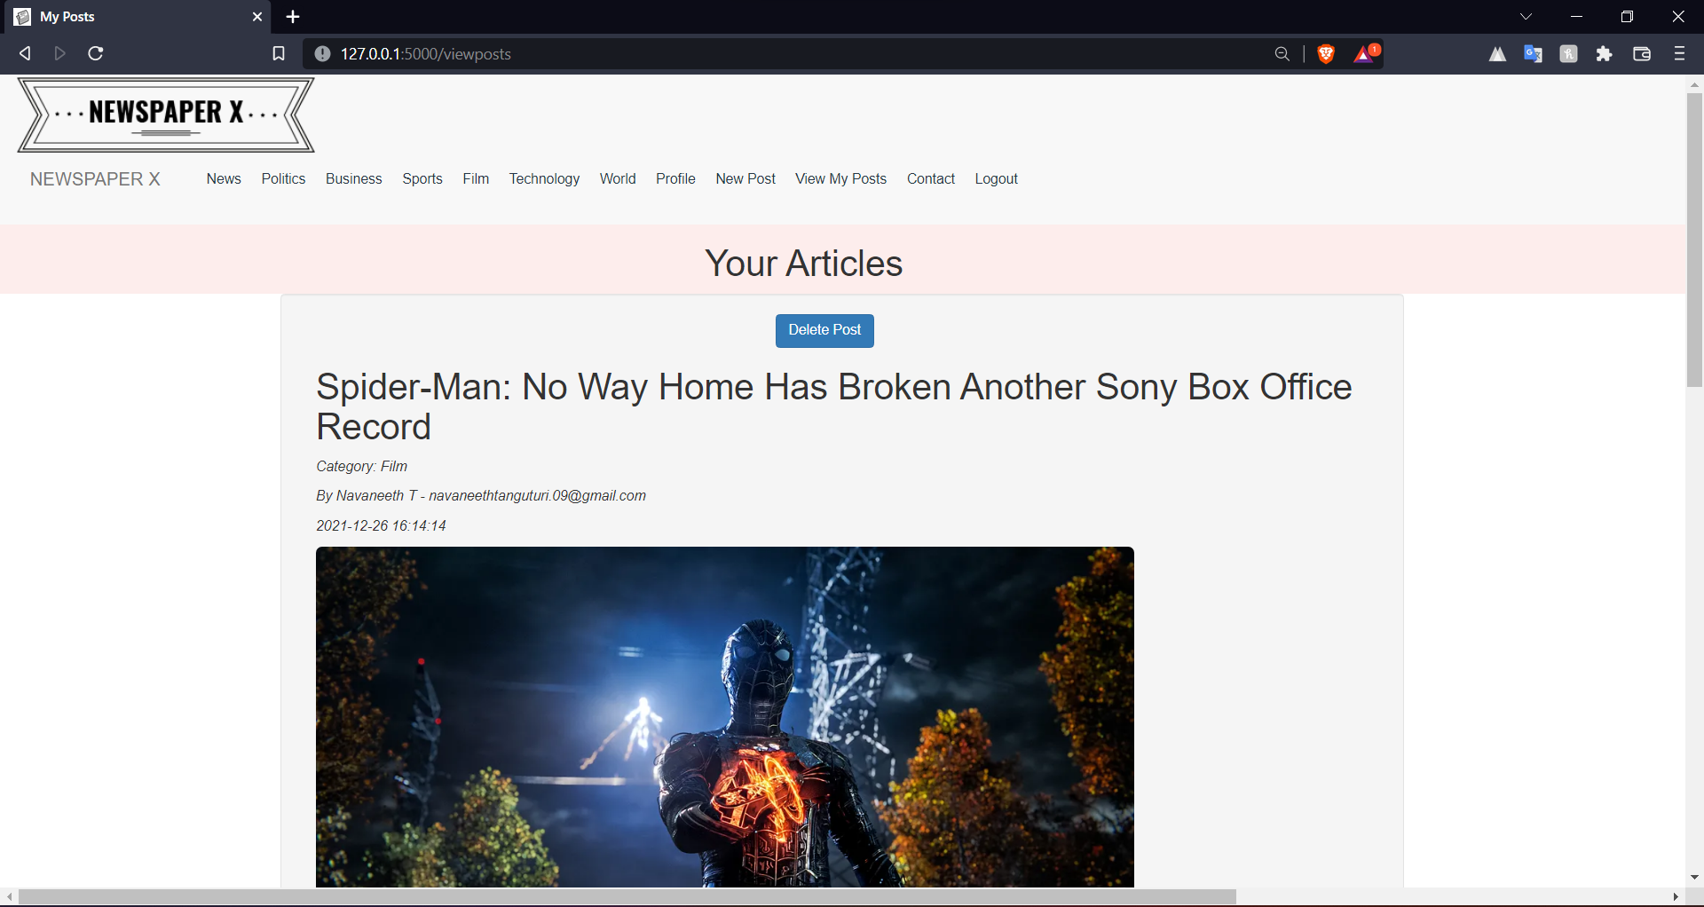

<html>

<head>

    <title> My Posts </title>

    <link rel="shortcut icon" type="image/x-icon" href="{{url_for('static', filename='favicon.png')}}">

    <link href="{{url_for('static', filename='css/bootstrap.css')}}" rel="stylesheet" type="text/css">

    <link href="{{url_for('static', filename='css/bootstrap.min.css')}}" rel="stylesheet" type="text/css">

    <link href="{{url_for('static', filename='css/style2.css')}}" rel="stylesheet" type="text/css">

    <style>

        #delete {

            margin-left: 370px;

        }

    </style>

</head>

<body>

    {% if "admin" in user %}

    {% include "adminheader.html" %}

    {% elif "editor" in user %}

    {% include "editorheader.html" %}

    {% else %}

    {% include "userheader.html" %}

    {%endif%}

    <form action="/viewposts" method="POST">

        <div>

            <div class="col-md-12 container divbg  vert-offset-top-1">

                <h1 class="col-md-offset-5"> Your Articles </h1>

            </div>

            {% for post in posts %}

            <div class="well divbg col-md-8 col-md-offset-2 vert-offset-top-3">

                <div class="col-md-3 col-md-offset-1 vert-offset-bottom-2"> <button type='submit'

                        class='btn btn-primary' name='submit_button' value='delete' id="delete"> Delete Post </button>

                </div>

                <div class="col-md-12 col-md-offset-0">

                    <h1> {{post[0]}} </h1>

                </div>

                <div class="col-md-12 col-md-offset-0"> <i>

                        <p> Category: {{post[1]}} </p>

                    </i> </div>

                <div class="col-md-12 col-md-offset-0">

                    <p> <i> By {{post[5][0]}} - {{post[5][1]}} </i> </p>

                </div>

                <div class="col-md-12 col-md-offset-0">

                    <p> <i> {{post[4]}} </i> </p>

                </div>

                <div class="col-md-12"> <img class="img-responsive img-rounded" height="500px" width="820px"

                        src={{post[2]}}> </div>

                <div class="col-md-12"> {{post[3]}}</div>

                <input type="hidden" name="aid" value="{{post[6]}}"/>

            </div>

            {%endfor%}

        </div>

    </form>

</body>

{% include "footer.html" %}

</html>

# 5.1.9) Verified Users

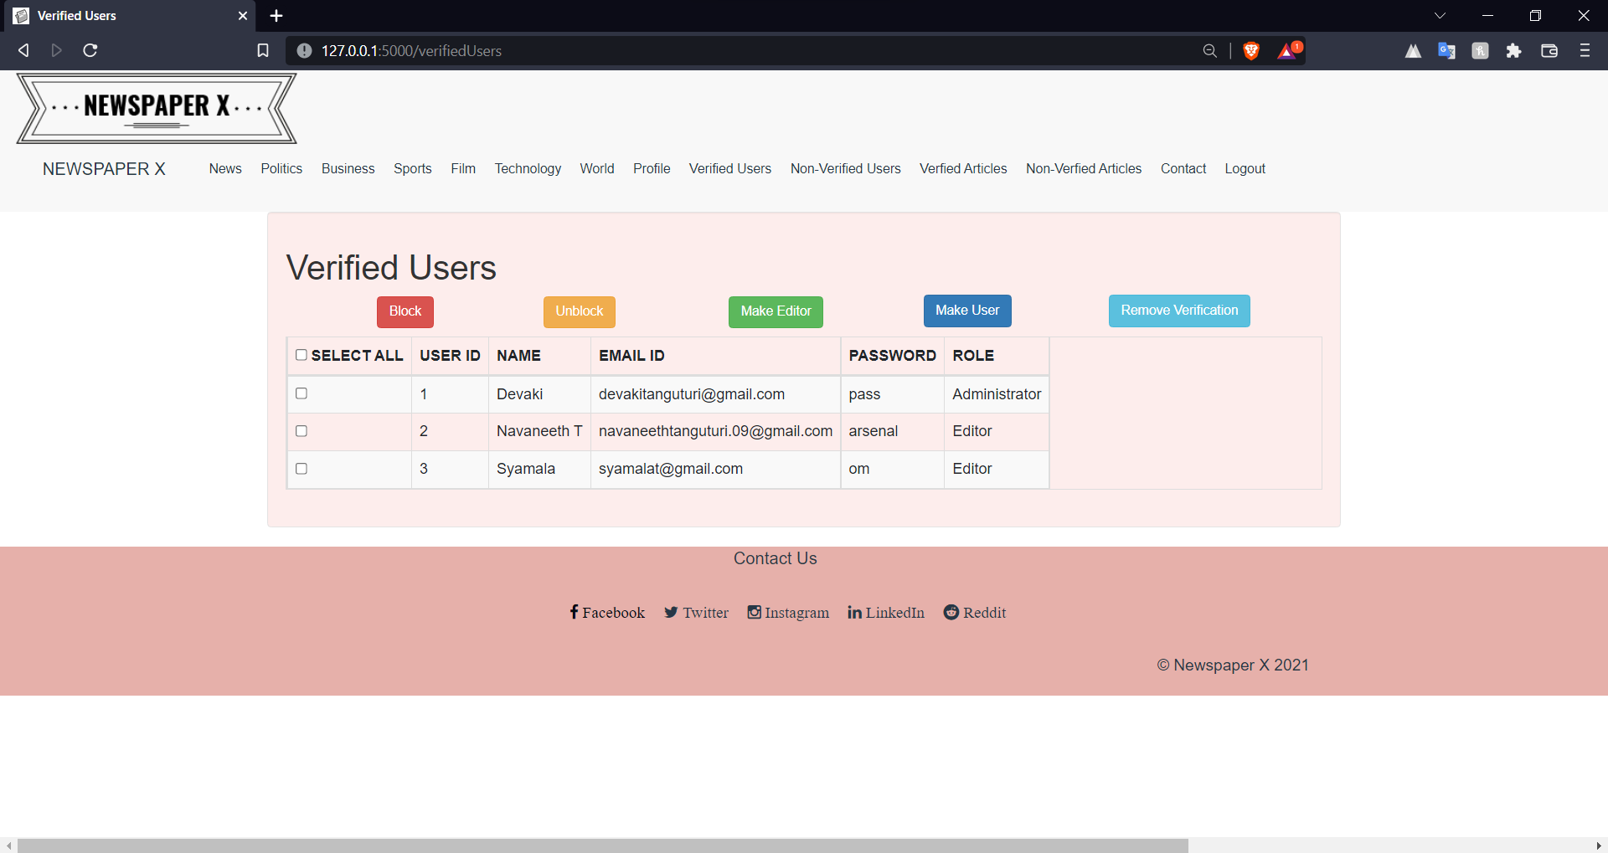

<html>

<head>

    <title> Verified Users </title>

    <link rel="shortcut icon" type="image/x-icon" href="{{url_for('static', filename='favicon.png')}}">

    <link href="{{url_for('static', filename='css/bootstrap.css')}}" rel="stylesheet" type="text/css">

    <link href="{{url_for('static', filename='css/bootstrap.min.css')}}" rel="stylesheet" type="text/css">

    <link href="{{url_for('static', filename='css/style2.css')}}" rel="stylesheet" type="text/css">

    <link href="https://maxcdn.bootstrapcdn.com/font-awesome/4.4.0/css/font-awesome.min.css" rel="stylesheet" />

    <link href="https://maxcdn.bootstrapcdn.com/bootstrap/3.3.5/css/bootstrap.min.css" rel="stylesheet" />

    <script src="https://ajax.googleapis.com/ajax/libs/jquery/3.1.1/jquery.min.js"> </script>

    <script src="https://maxcdn.bootstrapcdn.com/bootstrap/3.3.7/js/bootstrap.min.js"> </script>

    <script type="text/javascript">

        function selectAll(source) {

            checkboxes = document.getElementsByName('check[]');

            for (var i in checkboxes)

                checkboxes[i].checked = source.checked;

        }

    </script>

    <style>

        #block {

            margin-left: -10px;

        }

        #unblock {

            margin-left: -200px;

        }

        #mkeditor {

            margin-left: -370px;

        }

        #mkuser {

            margin-left: 570px;

            margin-top: -35px;

            margin-bottom: 10px;

        }

        #rmver{

            margin-left: 400px;

            margin-top: -35px;

            margin-bottom: 10px;

        }

    </style>

</head>

<body>

    {% include "adminheader.html" %}

    <form action="/verifiedUsers" method="POST">

        <div class="container well vert-offset-top-1" style="background: #FDEDEC">

            <h1> Verified Users </h1>

            <div class="col-md-3 col-md-offset-1 vert-offset-bottom-2"> <button type='submit' class='btn btn-danger'

                    name='submit_button' value='block' id="block"> Block </button> </div>

            <div class="col-md-3 col-md-offset-1 vert-offset-bottom-2"> <button type='submit' class='btn btn-warning'

                    name='submit_button' value='unblock' id="unblock"> Unblock </button> </div>

            <div class="col-md-3 col-md-offset-1 vert-offset-bottom-2"> <button type='submit' class='btn btn-success'

                    name='submit_button' value='mkeditor' id="mkeditor"> Make Editor </button> </div>

            <div class="col-md-3 col-md-offset-1 vert-offset-bottom-2"> <button type='submit' class='btn btn-primary'

                    name='submit_button' value='mkuser' id="mkuser"> Make User </button> </div>

            <div class="col-md-3 col-md-offset-1 vert-offset-bottom-2"> <button type='submit' class='btn btn-info'

                    name='submit_button' value='rmver' id="rmver"> Remove Verification </button> </div>

            <table class="table table-striped table-bordered table-responsive">

                <thead>

                    <tr>

                        <th> <input type="checkbox" name="check[]" onclick="selectAll(this)" value=""> SELECT ALL </th>

                        <th> USER ID </th>

                        <th> NAME </th>

                        <th> EMAIL ID </th>

                        <th> PASSWORD </th>

                        <th> ROLE </th>

                    </tr>

                </thead>

                <tbody>

                    {%for row in rows %}

                    <tr>

                        <td> <input type="checkbox" name="check[]" value={{row[0]}}></td>

                        {%for data in row%}

                        <td>{{data}}</td>

                        {%endfor%}

                    </tr>

                    {%endfor%}

                </tbody>

            </table>

        </div>

    </form>

</body>

{% include "footer.html" %}

</html>

# 5.1.10) Verified Articles

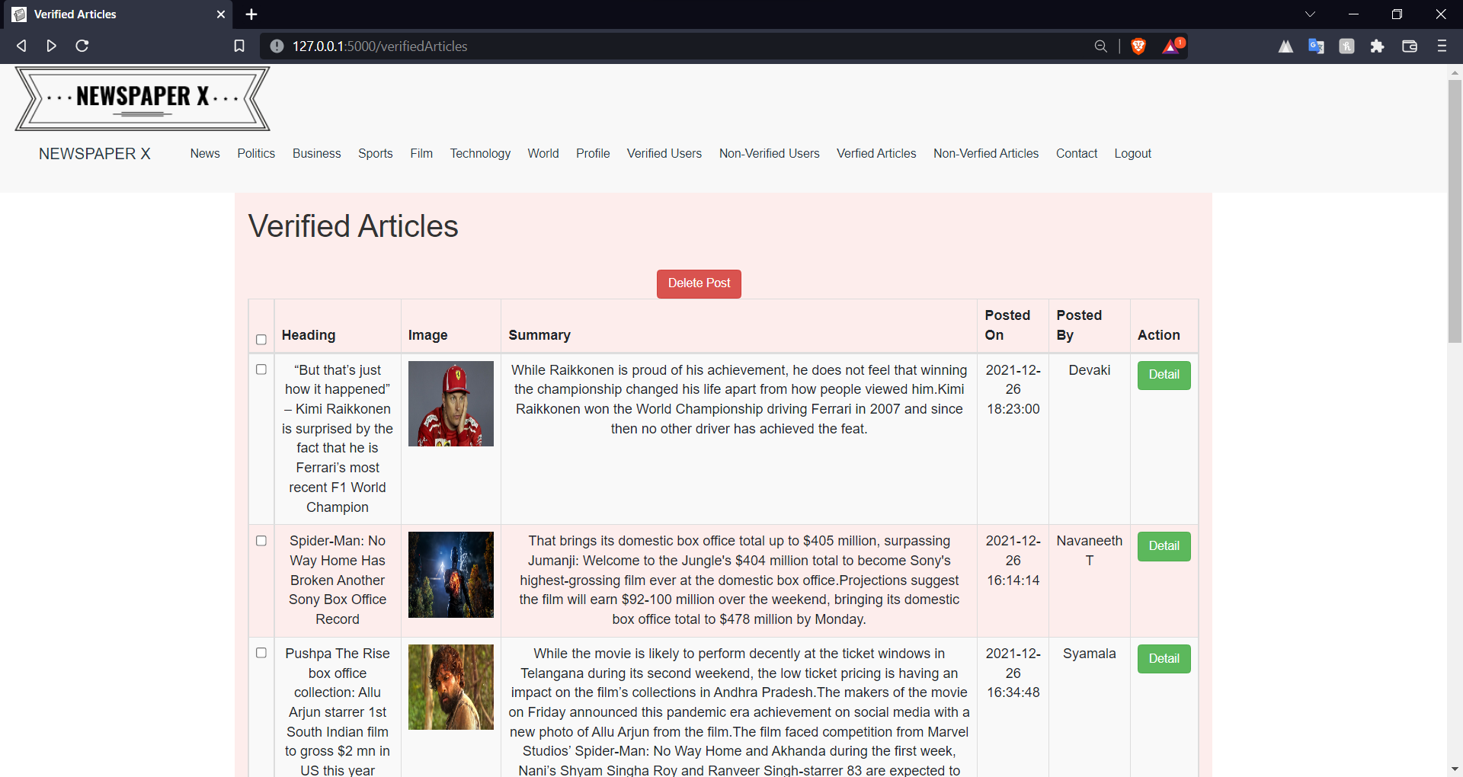

<html>

<head>

    <title>Verified Articles</title>

    <link rel="shortcut icon" type="image/x-icon" href="{{url_for('static', filename='favicon.png')}}">

    <link href="{{url_for('static', filename='css/bootstrap.css')}}" rel="stylesheet" type="text/css">

    <link href="{{url_for('static', filename='css/bootstrap.min.css')}}" rel="stylesheet" type="text/css">

    <link href="{{url_for('static', filename='css/style2.css')}}" rel="stylesheet" type="text/css">

    <link href="https://maxcdn.bootstrapcdn.com/font-awesome/4.4.0/css/font-awesome.min.css" rel="stylesheet" />

    <link href="https://maxcdn.bootstrapcdn.com/bootstrap/3.3.5/css/bootstrap.min.css" rel="stylesheet" />

    <script src="https://ajax.googleapis.com/ajax/libs/jquery/3.1.1/jquery.min.js"> </script>

    <script src="https://maxcdn.bootstrapcdn.com/bootstrap/3.3.7/js/bootstrap.min.js"> </script>

    <script type="text/javascript">

        function selectAll(source) {

            checkboxes = document.getElementsByName('check[]');

            for (var i in checkboxes)

                checkboxes[i].checked = source.checked;

        }

    </script>

    <style>

        body{

            overflow-x: hidden;

        }

        thead, tr, th, td{

            text-align: center;

        }

    </style>

</head>

<body>

   {% include "adminheader.html" %}

    <form action="/verifiedArticles" method="POST">

        <div class="container divbg vert-offset-top-1">

            <h1>Verified Articles </h1> <br>

            <div class="col-md-12 col-md-offset-5 vert-offset-bottom-2"> <button type='submit' class='btn btn-danger'

                    name='delete' value="delete"> Delete Post </button> </div>

            <table class="table table-striped table-bordered table-responsive">

                <thead>

                    <tr>

                        <th> <input type="checkbox" name="check[]" onClick="selectAll(this)"></th>

                        <th> Heading </th>

                        <th> Image </th>

                        <th> Summary </th>

                        <th> Posted On </th>

                        <th> Posted By </th>

                        <th> Action </th>

                    </tr>

                </thead>

                <tbody>

                    {% for row in rows %}

                    <tr>

                        <td> <input type="checkbox" name="check[]" value={{row[5]}}></td>

                        <td>

                            {{row[0]}}

                        </td>

                        <td> <img height="100px" width="100px" src={{row[1]}} alt="pic"></td>

                        <td>

                            {{row[2]}}

                        </td>

                        <td>

                            {{row[3]}}

                        </td>

                        <td>

                            {{row[4]}}

                        </td>

                        <td>

                            <a class="btn btn-success" href="/ReadPost{{row[5]}}"> Detail </a>

                        </td>

                    </tr>

                    {%endfor%}

                </tbody>

            </table>

        </div>

    </form>

    {% include "footer.html" %}

</body>

</html>

# 5.1.11) Non-Verified Users

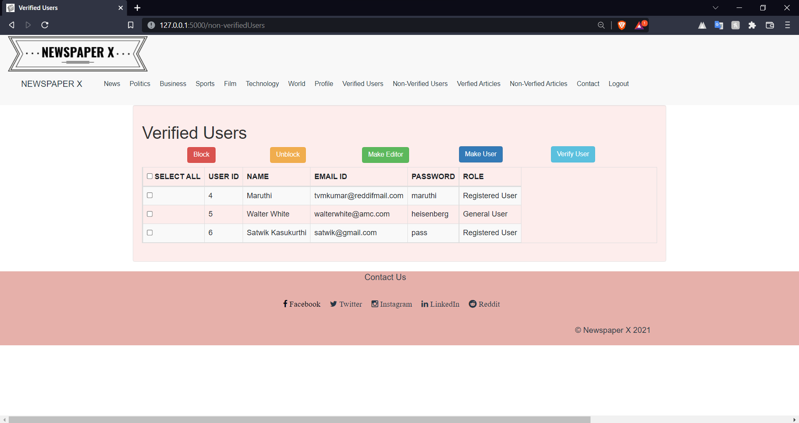

<html>

<head>

    <title> Verified Users </title>

    <link rel="shortcut icon" type="image/x-icon" href="{{url_for('static', filename='favicon.png')}}">

    <link href="{{url_for('static', filename='css/bootstrap.css')}}" rel="stylesheet" type="text/css">

    <link href="{{url_for('static', filename='css/bootstrap.min.css')}}" rel="stylesheet" type="text/css">

    <link href="{{url_for('static', filename='css/style2.css')}}" rel="stylesheet" type="text/css">

    <link href="https://maxcdn.bootstrapcdn.com/font-awesome/4.4.0/css/font-awesome.min.css" rel="stylesheet" />

    <link href="https://maxcdn.bootstrapcdn.com/bootstrap/3.3.5/css/bootstrap.min.css" rel="stylesheet" />

    <script src="https://ajax.googleapis.com/ajax/libs/jquery/3.1.1/jquery.min.js"> </script>

    <script src="https://maxcdn.bootstrapcdn.com/bootstrap/3.3.7/js/bootstrap.min.js"> </script>

    <script type="text/javascript">

        function selectAll(source) {

            checkboxes = document.getElementsByName('check[]');

            for (var i in checkboxes)

                checkboxes[i].checked = source.checked;

        }

    </script>

    <style>

        #block {

            margin-left: -10px;

        }

        #unblock {

            margin-left: -200px;

        }

        #mkeditor {

            margin-left: -370px;

        }

        #mkuser {

            margin-left: 570px;

            margin-top: -35px;

            margin-bottom: 10px;

        }

        #rmver {

            margin-left: 400px;

            margin-top: -35px;

            margin-bottom: 10px;

        }

    </style>

</head>

<body>

    {% include "adminheader.html" %}

    <form action="/non-verifiedUsers" method="POST">

        <div class="container well vert-offset-top-1" style="background: #FDEDEC">

            <h1> Verified Users </h1>

            <div class="col-md-3 col-md-offset-1 vert-offset-bottom-2"> <button type='submit' class='btn btn-danger'

                    name='submit_button' value='block' id="block"> Block </button> </div>

            <div class="col-md-3 col-md-offset-1 vert-offset-bottom-2"> <button type='submit' class='btn btn-warning'

                    name='submit_button' value='unblock' id="unblock"> Unblock </button> </div>

            <div class="col-md-3 col-md-offset-1 vert-offset-bottom-2"> <button type='submit' class='btn btn-success'

                    name='submit_button' value='mkeditor' id="mkeditor"> Make Editor </button> </div>

            <div class="col-md-3 col-md-offset-1 vert-offset-bottom-2"> <button type='submit' class='btn btn-primary'

                    name='submit_button' value='mkuser' id="mkuser"> Make User </button> </div>

            <div class="col-md-3 col-md-offset-1 vert-offset-bottom-2"> <button type='submit' class='btn btn-info'

                    name='submit_button' value='rmver' id="rmver"> Verify User </button> </div>

            <table class="table table-striped table-bordered table-responsive">

                <thead>

                    <tr>

                        <th> <input type="checkbox" name="check[]" onclick="selectAll(this)" value=""> SELECT ALL </th>

                        <th> USER ID </th>

                        <th> NAME </th>

                        <th> EMAIL ID </th>

                        <th> PASSWORD </th>

                        <th> ROLE </th>

                    </tr>

                </thead>

                <tbody>

                    {%for row in rows %}

                    <tr>

                        <td> <input type="checkbox" name="check[]" value={{row[0]}}></td>

                        {%for data in row%}

                        <td>{{data}}</td>

                        {%endfor%}

                    </tr>

                    {%endfor%}

                </tbody>

            </table>

        </div>

    </form>

</body>

{% include "footer.html" %}

</html>

# 5.1.12) Non-Verified Articles

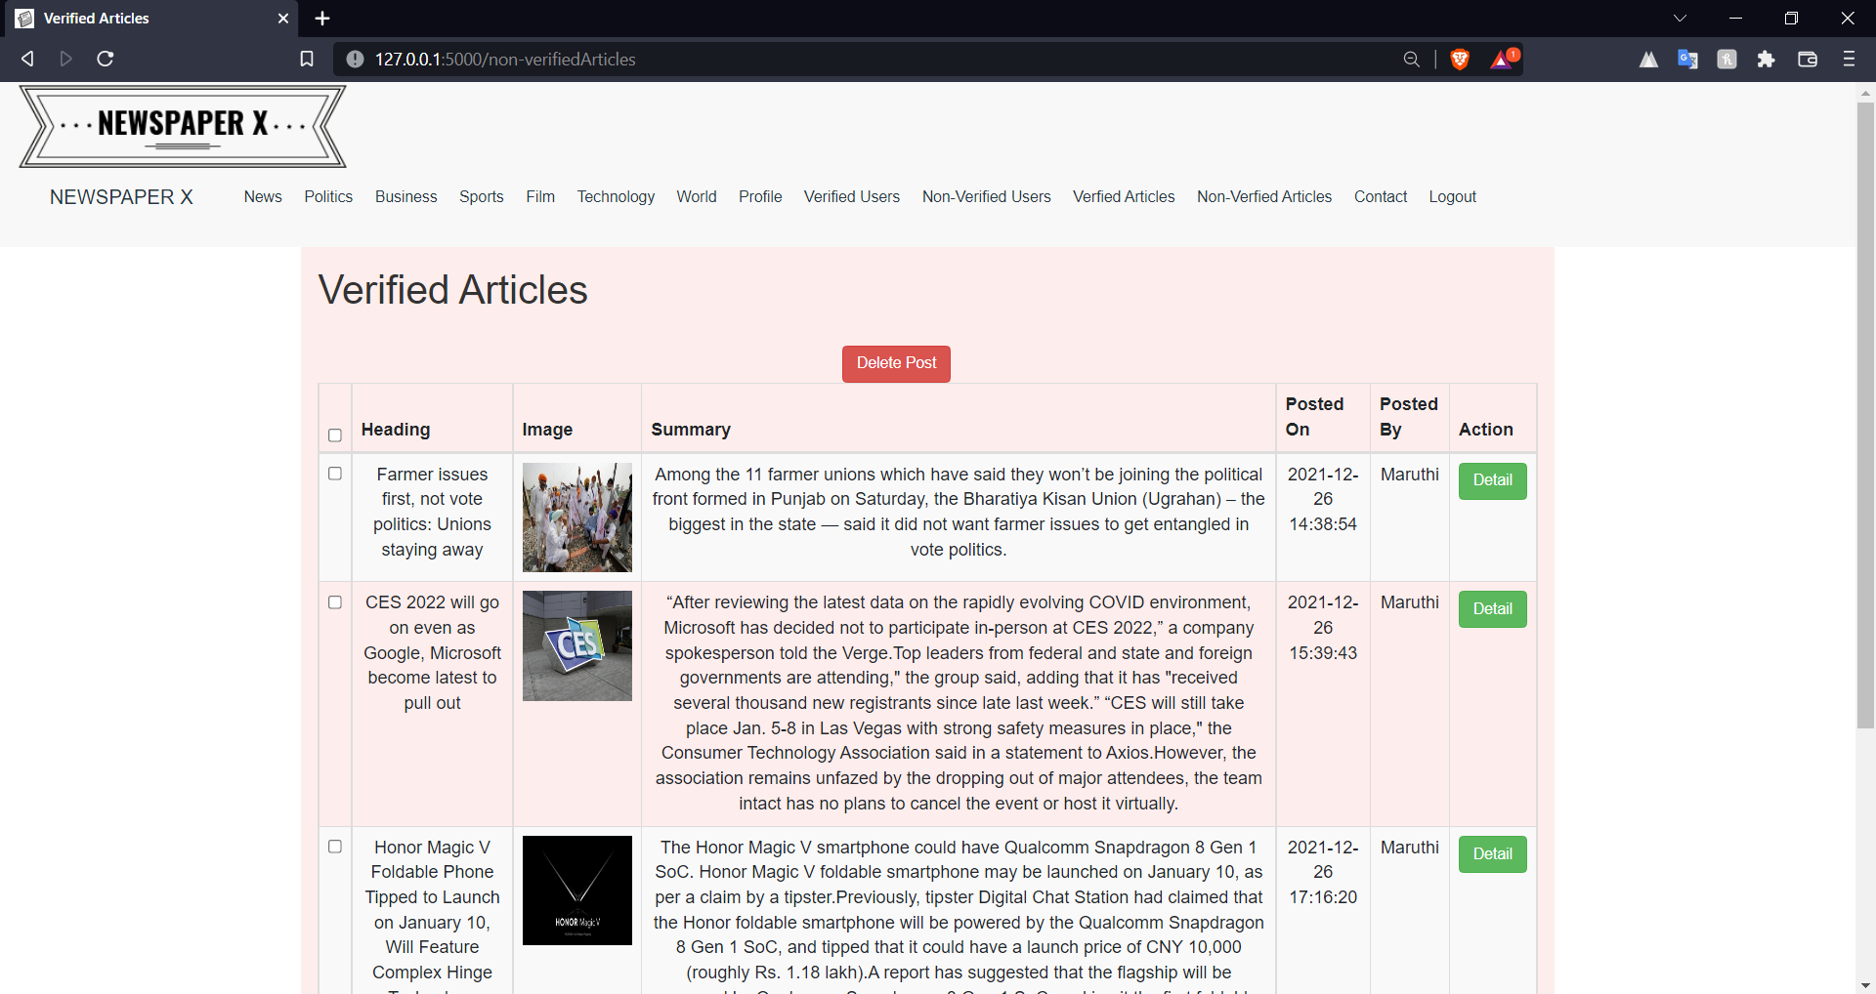

<html>

<head>

    <title>Non-Verified Articles</title>

    <link rel="shortcut icon" type="image/x-icon" href="{{url_for('static', filename='favicon.png')}}">

    <link href="{{url_for('static', filename='css/bootstrap.css')}}" rel="stylesheet" type="text/css">

    <link href="{{url_for('static', filename='css/bootstrap.min.css')}}" rel="stylesheet" type="text/css">

    <link href="{{url_for('static', filename='css/style2.css')}}" rel="stylesheet" type="text/css">

    <link href="https://maxcdn.bootstrapcdn.com/font-awesome/4.4.0/css/font-awesome.min.css" rel="stylesheet" />

    <link href="https://maxcdn.bootstrapcdn.com/bootstrap/3.3.5/css/bootstrap.min.css" rel="stylesheet" />

    <script src="https://ajax.googleapis.com/ajax/libs/jquery/3.1.1/jquery.min.js"> </script>

    <script src="https://maxcdn.bootstrapcdn.com/bootstrap/3.3.7/js/bootstrap.min.js"> </script>

    <script type="text/javascript">

        function selectAll(source) {

            checkboxes = document.getElementsByName('check[]');

            for (var i in checkboxes)

                checkboxes[i].checked = source.checked;

        }

    </script>

    <style>

        body{

            overflow-x: hidden;

        }

        thead, tr, th, td{

            text-align: center;

        }

    </style>

</head>

<body>

   {% include "adminheader.html" %}

    <form action="/verifiedArticles" method="POST">

        <div class="container divbg vert-offset-top-1">

            <h1>Verified Articles </h1> <br>

            <div class="col-md-12 col-md-offset-5 vert-offset-bottom-2"> <button type='submit' class='btn btn-danger'

                    name='delete' value="delete"> Delete Post </button> </div>

            <table class="table table-striped table-bordered table-responsive">

                <thead>

                    <tr>

                        <th> <input type="checkbox" name="check[]" onClick="selectAll(this)"></th>

                        <th> Heading </th>

                        <th> Image </th>

                        <th> Summary </th>

                        <th> Posted On </th>

                        <th> Posted By </th>

                        <th> Action </th>

                    </tr>

                </thead>

                <tbody>

                    {% for row in rows %}

                    <tr>

                        <td> <input type="checkbox" name="check[]" value={{row[5]}}></td>

                        <td>

                            {{row[0]}}

                        </td>

                        <td> <img height="100px" width="100px" src={{row[1]}} alt="pic"></td>

                        <td>

                            {{row[2]}}

                        </td>

                        <td>

                            {{row[3]}}

                        </td>

                        <td>

                            {{row[4]}}

                        </td>

                        <td>

                            <a class="btn btn-success" href="/ReadPost{{row[5]}}"> Detail </a>

                        </td>

                    </tr>

                    {%endfor%}

                </tbody>

            </table>

        </div>

    </form>

    {% include "footer.html" %}

</body>

</html>

# 5.1.13) Reading Live News

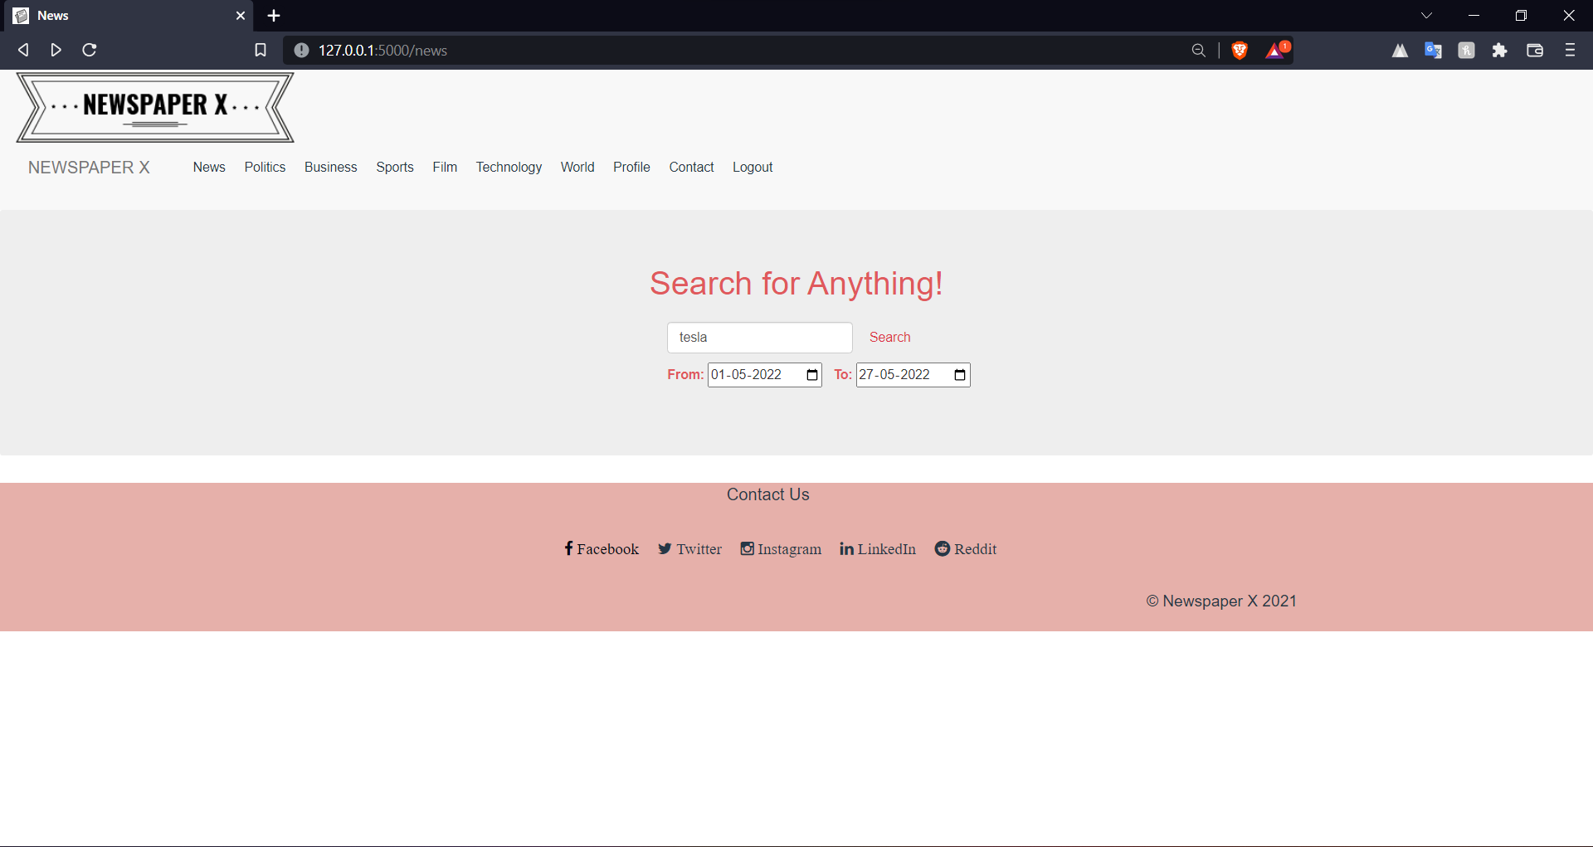

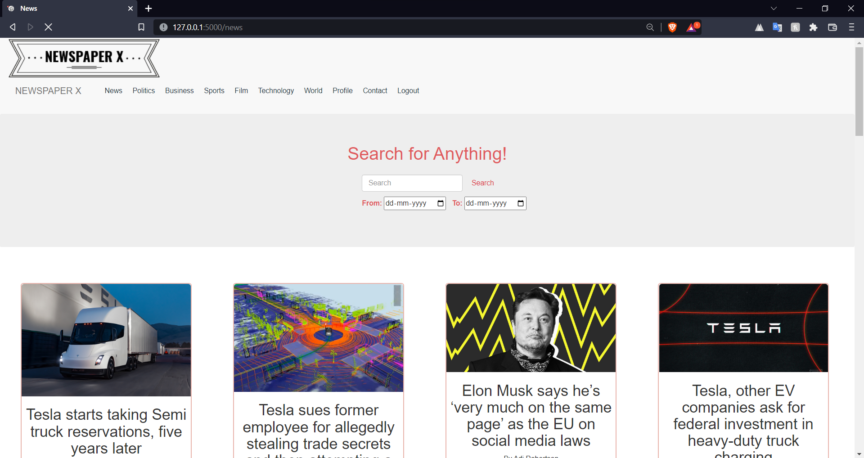

<html>

<head>

    <title> News </title>

    <link rel="shortcut icon" type="image/x-icon" href="{{url_for('static', filename='favicon.png')}}">

    <link href="{{url_for('static', filename='css/bootstrap.css')}}" rel="stylesheet" type="text/css">

    <link href="{{url_for('static', filename='css/bootstrap.min.css')}}" rel="stylesheet" type="text/css">

    <link href="{{url_for('static', filename='css/style2.css')}}" rel="stylesheet" type="text/css">

    <link rel="stylesheet" type="text/css" href="{{url_for('static', filename='css/cards.css')}}">

    <style>

        body {

            overflow-x: hidden;

        }

        #searchbar {

            margin-left: 670px;

            padding: 10px;

        }

        .dates{

            margin-left: 40px;

        }

    </style>

</head>

<body>

    {% if "admin" in user %}

    {% include "adminheader.html" %}

    {% elif "editor" in user %}

    {% include "editorheader.html" %}

    {% else %}

    {% include "userheader.html" %}

    {%endif%}

    <div class="jumbotron">

        <h5 class="display-4" style="text-align: center; color: #e0595c;">Search for Anything!</h5>

        <div class="row" id="searchbar">

            <div class="col-md-6 mb-4">

                <form class="form-inline" method="POST">

                    <input class="form-control mr-sm-2" name="searchbar" type="search" placeholder="Search"

                        aria-label="Search">

                    <button class="btn btn-outline-danger my-2 my-sm-0" type="submit">Search</button>

                    <div class="form-inline" style="margin-top: 10px;">

                        <label for="from" style="color: #e0595c;">From:&nbsp;</label>

                        <input type="date" id="from" name="from">&nbsp;&nbsp;&nbsp;

                        <label for="to" style="color: #e0595c;">To:&nbsp;</label>

                        <input type="date" id="to" name="to">

                    </div>

                </form>

            </div>

        </div>

    </div>

    {% for article in articles %}

    <div class="main">

        <form action="/readURL" method="POST">

            <div class="cards">

                <div class="img">

                    <a href={{article['url']}}> <img id="cardImage" src={{article['urlToImage']}}>

                    </a>

                </div>

                <div class="title">

                    <h2 name="title">{{article['title']}}</h2>

                    <p name="author">By {{article['author']}}</p>

                </div>

                <div class="description">

                    <p>{{article['description']}}</p>

                    <button name="ReadMore" id="ReadMore">...Read More</button>

                </div>

                <div>

                    <input type="hidden" name="author" value="{{article['author']}}">

                    <input type="hidden" name="title" value="{{article['title']}}">

                    <input type="hidden" name="URL" value="{{article['url']}}">

                    <input type="hidden" name="date" value="{{article['publishedAt']}}">

                    <input type="hidden" name="content" value="{{article['content']}}">

                    <input type="hidden" name="source" value="{{article['urlToImage']}}">

                </div>

            </div>

        </form>

    </div>

    {% endfor %}

    {% include "footer.html" %}

</body>

</html>

# 5.1.14) Read Live News

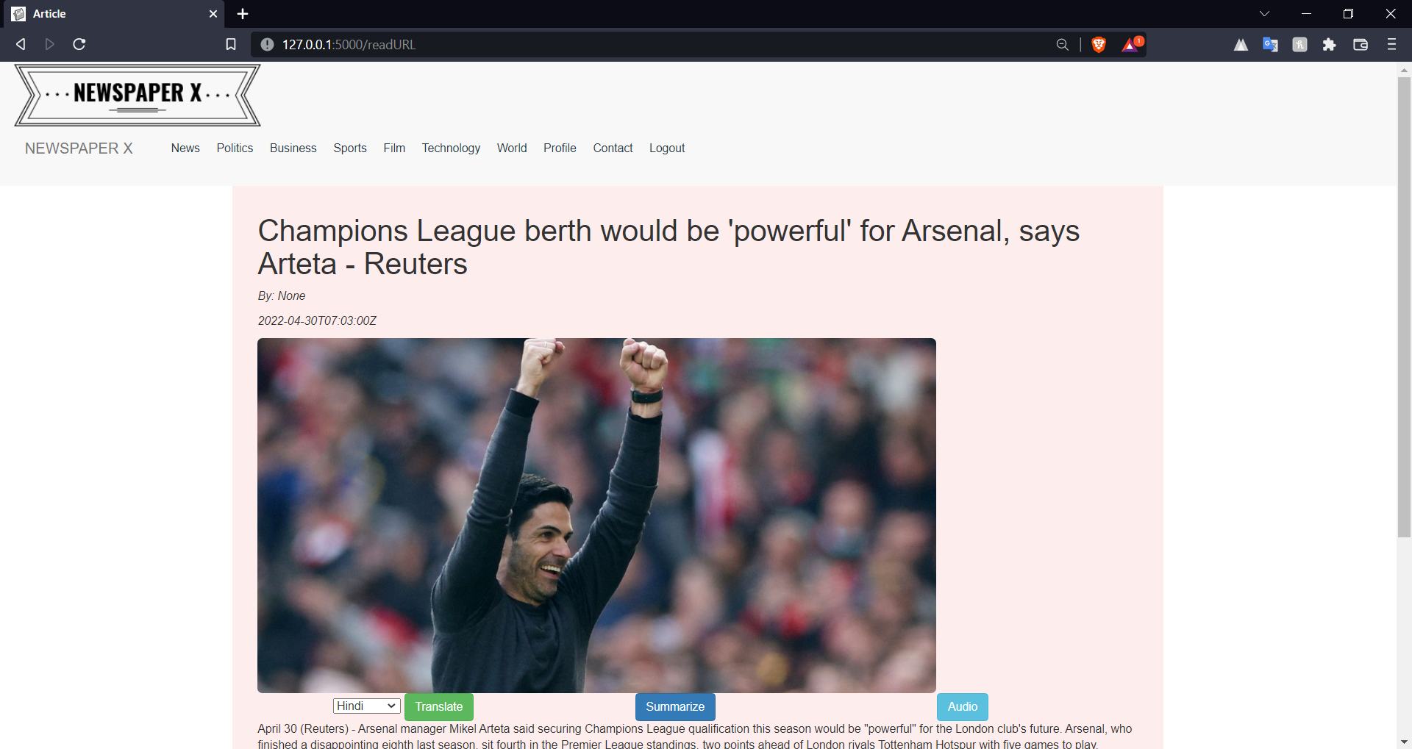

<html>

<head>

    <title> Article </title>

    <link rel="shortcut icon" type="image/x-icon" href="{{url_for('static', filename='favicon.png')}}">

    <link href="{{url_for('static', filename='css/bootstrap.css')}}" rel="stylesheet" type="text/css">

    <link href="{{url_for('static', filename='css/bootstrap.min.css')}}" rel="stylesheet" type="text/css">

    <link href="{{url_for('static', filename='css/style2.css')}}" rel="stylesheet" type="text/css">

    <link href="https://maxcdn.bootstrapcdn.com/font-awesome/4.4.0/css/font-awesome.min.css" rel="stylesheet" />

    <link href="https://maxcdn.bootstrapcdn.com/bootstrap/3.3.5/css/bootstrap.min.css" rel="stylesheet" />

    <script src="https://ajax.googleapis.com/ajax/libs/jquery/3.1.1/jquery.min.js"> </script>

    <script src="https://maxcdn.bootstrapcdn.com/bootstrap/3.3.7/js/bootstrap.min.js"> </script>

    <style>

        body{

            overflow-x: hidden;

        }

    </style>

</head>

<body>

    {% if "admin" in user %}

    {% include "adminheader.html" %}

    {% elif "editor" in user %}

    {% include "editorheader.html" %}

    {% else %}

    {% include "userheader.html" %}

    {%endif%}

    {% for mesg in get_flashed_messages() %}

    <p style="text-align: center; color: crimson;">{{mesg}}</p>

    {% endfor %}

    <div class="container divbg col-md-8 col-md-offset-2 vert-offset-top-2" style="padding: 15px">

        <form action="/ReadPostURL" method="POST">

            <div class="col-md-12 col-md-offset-0">

                <h1>

                    {{heading}}

                </h1>

            </div>

            <div class="col-md-12 col-md-offset-0">

                <p> <i>

                        By: {{name}}

                    </i> </p>

            </div>

            <div class="col-md-12 col-md-offset-0">

                <p> <i>

                        {{date}}

                    </i> </p>

            </div>

            <div class="col-md-12"> <a href={{sourceURL}}><img class="img-responsive img-rounded" height="500px" width="820px" src={{source}}

                    alt="#"></a></div>

            <div class="col-md-3 col-md-offset-1 vert-offset-bottom-2">

                <select class="form-select form-select-sm" aria-label=".form-select-sm example" id="select" name = "language">

                    <option name="hi" value = "Hindi"selected>Hindi</option>

                    <option name="te" value="Telugu">Telugu</option>

                    <option name="ta" value="Tamil">Tamil</option>

                    <option name="kn" value="Kannada">Kannada</option>

                  </select>

                <button type='submit' class='btn btn-success'

                    name='submit_button' value='Translate' id="Translate"> Translate

                </button>

            </div>

            <div class="col-md-3 col-md-offset-1 vert-offset-bottom-2"> <button type='submit' class='btn btn-primary'

                    name='submit_button' value='Summarize' id="Summarize"> Summarize </button> </div>

            <div class="col-md-3 col-md-offset-1 vert-offset-bottom-2"> <button type='submit' class='btn btn-info'

                    name='submit_button' value='Audio' id="Audio"> Audio </button> </div>

            <div class="col-md-12">

                {{description}}

            </div>

            <input type="hidden" name="description" value="{{description}}"/>

            <input type="hidden" name="name" value="{{name}}"/>

            <input type="hidden" name="date" value="{{date}}"/>

            <input type="hidden" name="heading" value="{{heading}}"/>

            <input type="hidden" name="source" value="{{source}}"/>

        </form>

    </div>

</body>

{% include "footer.html" %}

</html>

# 5.1.15) Read Full Post

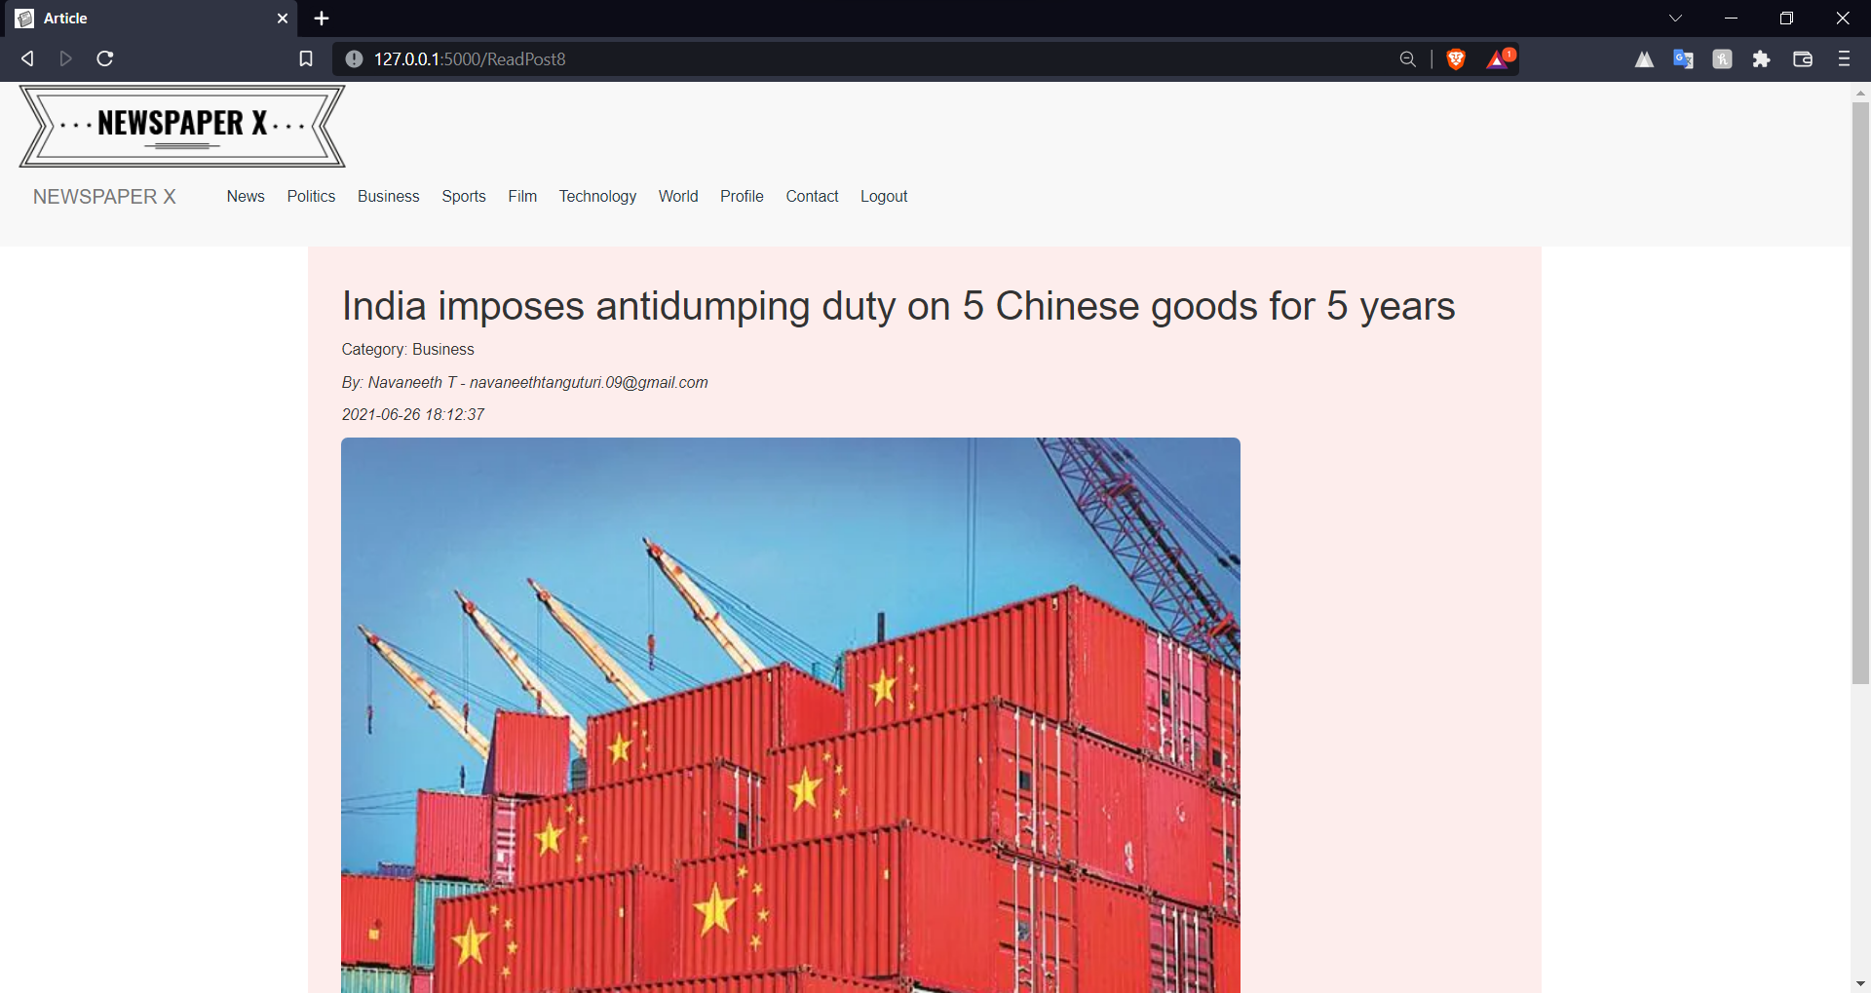

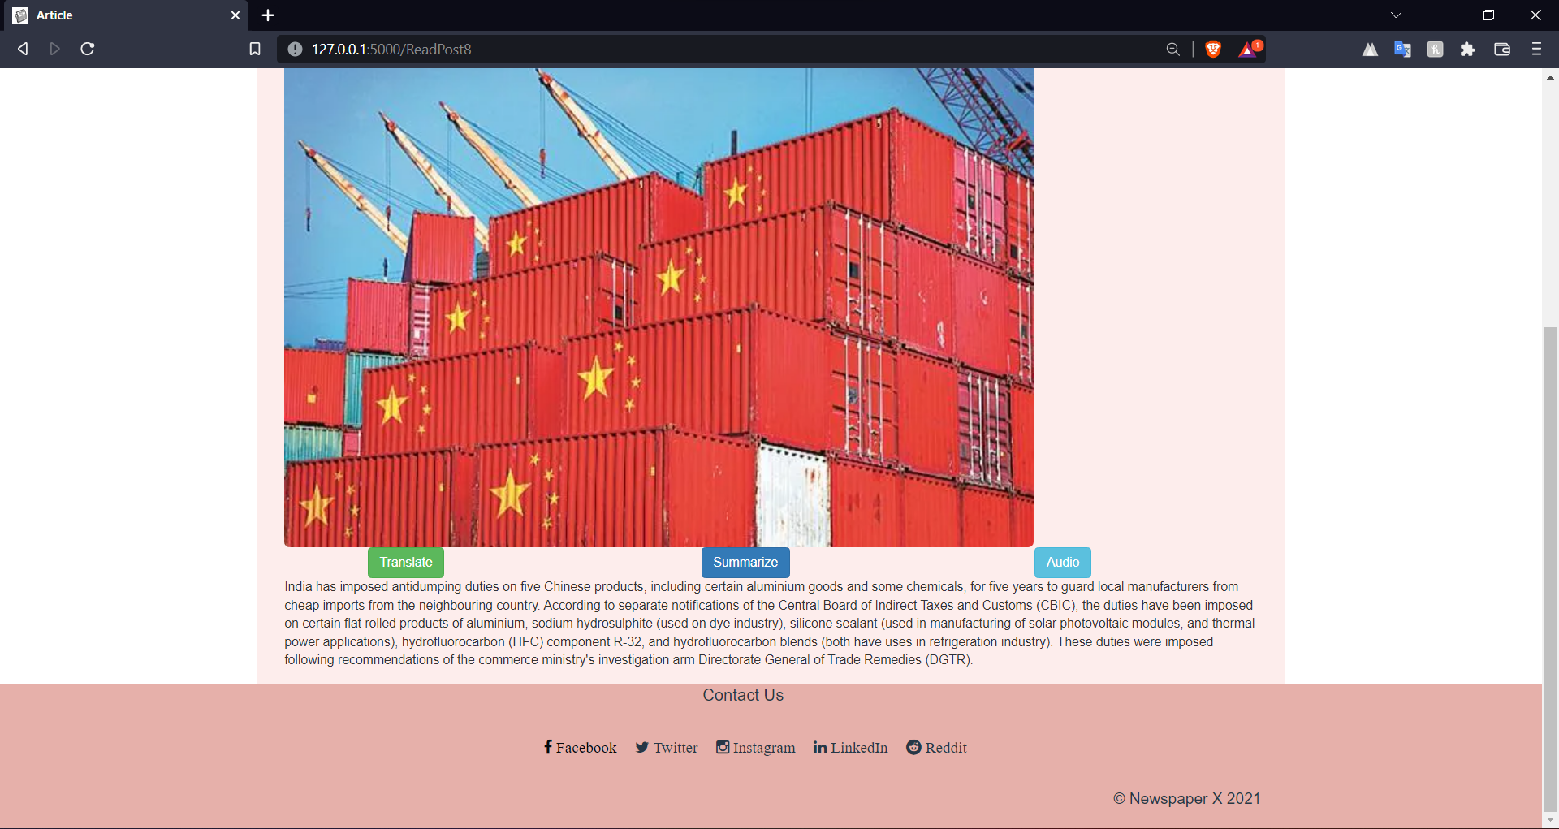

<html>

<head>

    <title> Article </title>

    <link rel="shortcut icon" type="image/x-icon" href="{{url_for('static', filename='favicon.png')}}">

    <link href="{{url_for('static', filename='css/bootstrap.css')}}" rel="stylesheet" type="text/css">

    <link href="{{url_for('static', filename='css/bootstrap.min.css')}}" rel="stylesheet" type="text/css">

    <link href="{{url_for('static', filename='css/style2.css')}}" rel="stylesheet" type="text/css">

    <link href="https://maxcdn.bootstrapcdn.com/font-awesome/4.4.0/css/font-awesome.min.css" rel="stylesheet" />

    <link href="https://maxcdn.bootstrapcdn.com/bootstrap/3.3.5/css/bootstrap.min.css" rel="stylesheet" />

    <script src="https://ajax.googleapis.com/ajax/libs/jquery/3.1.1/jquery.min.js"> </script>

    <script src="https://maxcdn.bootstrapcdn.com/bootstrap/3.3.7/js/bootstrap.min.js"> </script>

    <style>

        body{

            overflow-x: hidden;

        }

    </style>

</head>

<body>

    {% if "admin" in user %}

    {% include "adminheader.html" %}

    {% elif "editor" in user %}

    {% include "editorheader.html" %}

    {% else %}

    {% include "userheader.html" %}

    {%endif%}

    {% for mesg in get_flashed_messages() %}

    <p style="text-align: center; color: crimson;">{{mesg}}</p>

    {% endfor %}

    <div class="container divbg col-md-8 col-md-offset-2 vert-offset-top-2" style="padding: 15px">

        <form action="/ReadPost{{aid}}" method="POST">

            <div class="col-md-12 col-md-offset-0">

                <h1>

                    {{heading}}

                </h1>

            </div>

            <div class="col-md-12 col-md-offset-0">

                <p> Category: {{category}}

                </p>

            </div>

            <div class="col-md-12 col-md-offset-0">

                <p> <i>

                        By: {{name}} - {{email}}

                    </i> </p>

            </div>

            <div class="col-md-12 col-md-offset-0">

                <p> <i>

                        {{date}}

                    </i> </p>

            </div>

            <div class="col-md-12"> <img class="img-responsive img-rounded" height="500px" width="820px" src={{source}}

                    alt="#"> </div>

            <div class="col-md-3 col-md-offset-1 vert-offset-bottom-2"> <button type='submit' class='btn btn-success'

                    name='submit_button' value='Translate' id="Translate"> Translate </button> </div>

            <div class="col-md-3 col-md-offset-1 vert-offset-bottom-2"> <button type='submit' class='btn btn-primary'

                    name='submit_button' value='Summarize' id="Summarize"> Summarize </button> </div>

            <div class="col-md-3 col-md-offset-1 vert-offset-bottom-2"> <button type='submit' class='btn btn-info'

                    name='submit_button' value='Audio' id="Audio"> Audio </button> </div>

            <div class="col-md-12">

                {{description}}

            </div>

        </form>

    </div>

</body>

{% include "footer.html" %}

</html>

# 5.1.16) Viewing All News

Code

<html>

<head>

    <title> {{news}} </title>

    <link rel="shortcut icon" type = "image/x-icon" href = "{{url_for('static', filename='favicon.png')}}">

    <link href="{{url_for('static', filename='css/bootstrap.css')}}" rel="stylesheet" type="text/css">

    <link href="{{url_for('static', filename='css/bootstrap.min.css')}}" rel="stylesheet" type="text/css">

    <link href="{{url_for('static', filename='css/style2.css')}}" rel="stylesheet" type="text/css">

    <style>

        body {

            overflow-x: hidden;

        }

    </style>

</head>

<body action="/news" method="POST">

    {% if "admin" in user %}

        {% include "adminheader.html" %}

    {% elif "editor" in user %}

        {% include "editorheader.html" %}

    {% else %}

        {% include "userheader.html" %}

    {%endif%}

    <div>

        <div class="col-md-12 container divbg vert-offset-top-1 display-3 jumbotron" style="background-color: #e7b0ab;">

            <h1 class="col-md-offset-4"> Latest News </h1>

        </div>

        {%for post in posts %}

        <div class="well divbg col-md-8 col-md-offset-2 vert-offset-top-3">

            <div class="col-md-12 col-md-offset-0">

                <h1> {{post[0]}} </h1>

            </div>

            <div class="col-md-12 col-md-offset-0"> <i>

                    <p> Category: {{post[1]}} </p>

                </i> </div>

            <div class="col-md-12 col-md-offset-0">

                <p> <i> By {{post[5][0]}} - {{post[5][1]}} </i> </p>

            </div>

            <div class="col-md-12 col-md-offset-0">

                <p> <i> {{post[4]}} </i> </p>

            </div>

            <div class="col-md-12"> <img class="img-responsive img-rounded" height="500px" width="820px" src={{post[2]}}

                    > </div>

            <div class="col-md-12"> {{post[3][:500]}} <a href="/ReadPost{{post[6]}}">...Read More</a></div>

        </div>

        {%endfor%}

    </div>

</body>

{% include "footer.html" %}

</html>

# 5.1.16.1) Viewing news of category ‘Politics’

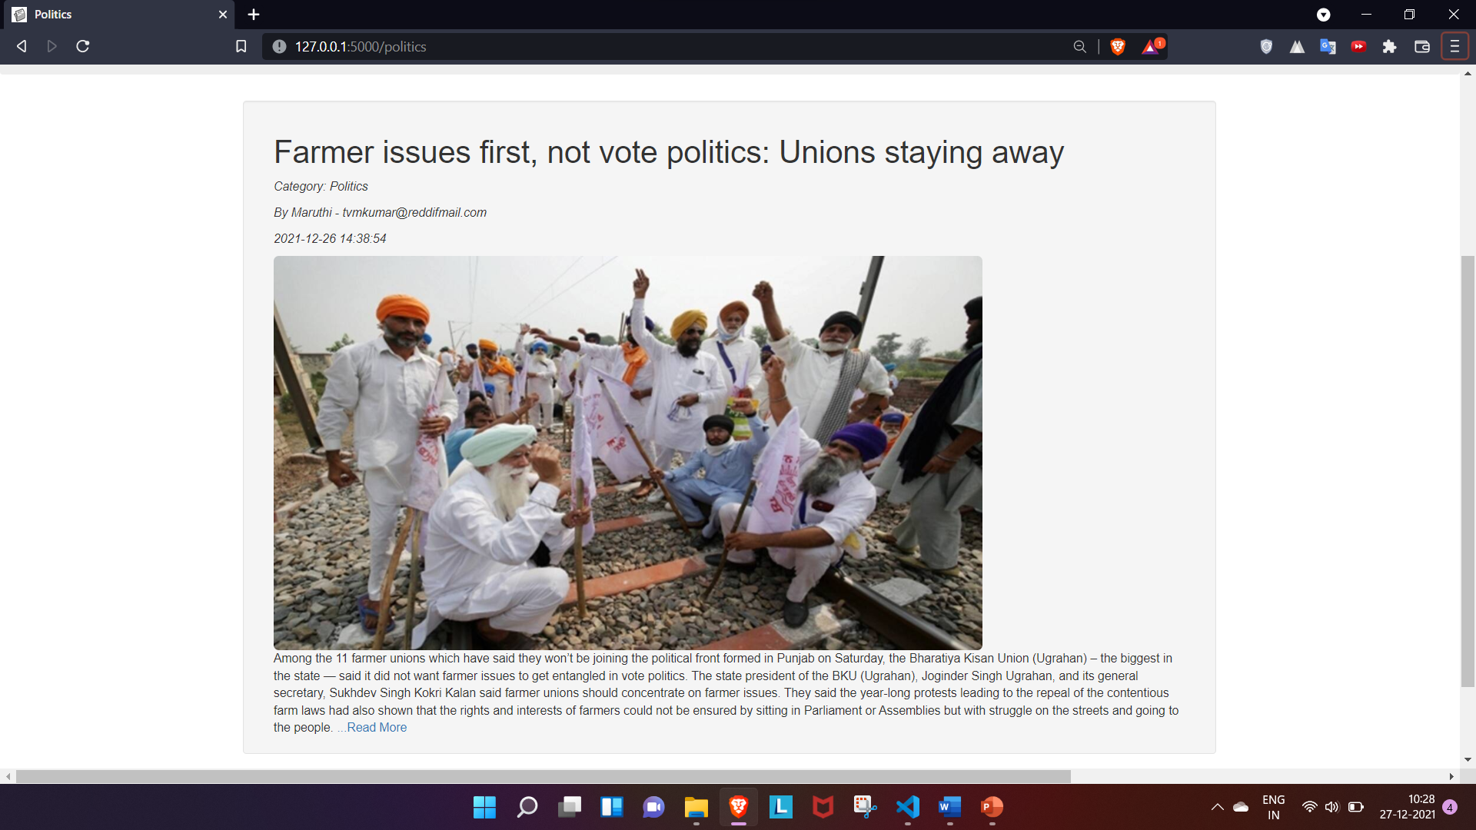

# 5.1.16.2) Viewing news of category ‘Business’

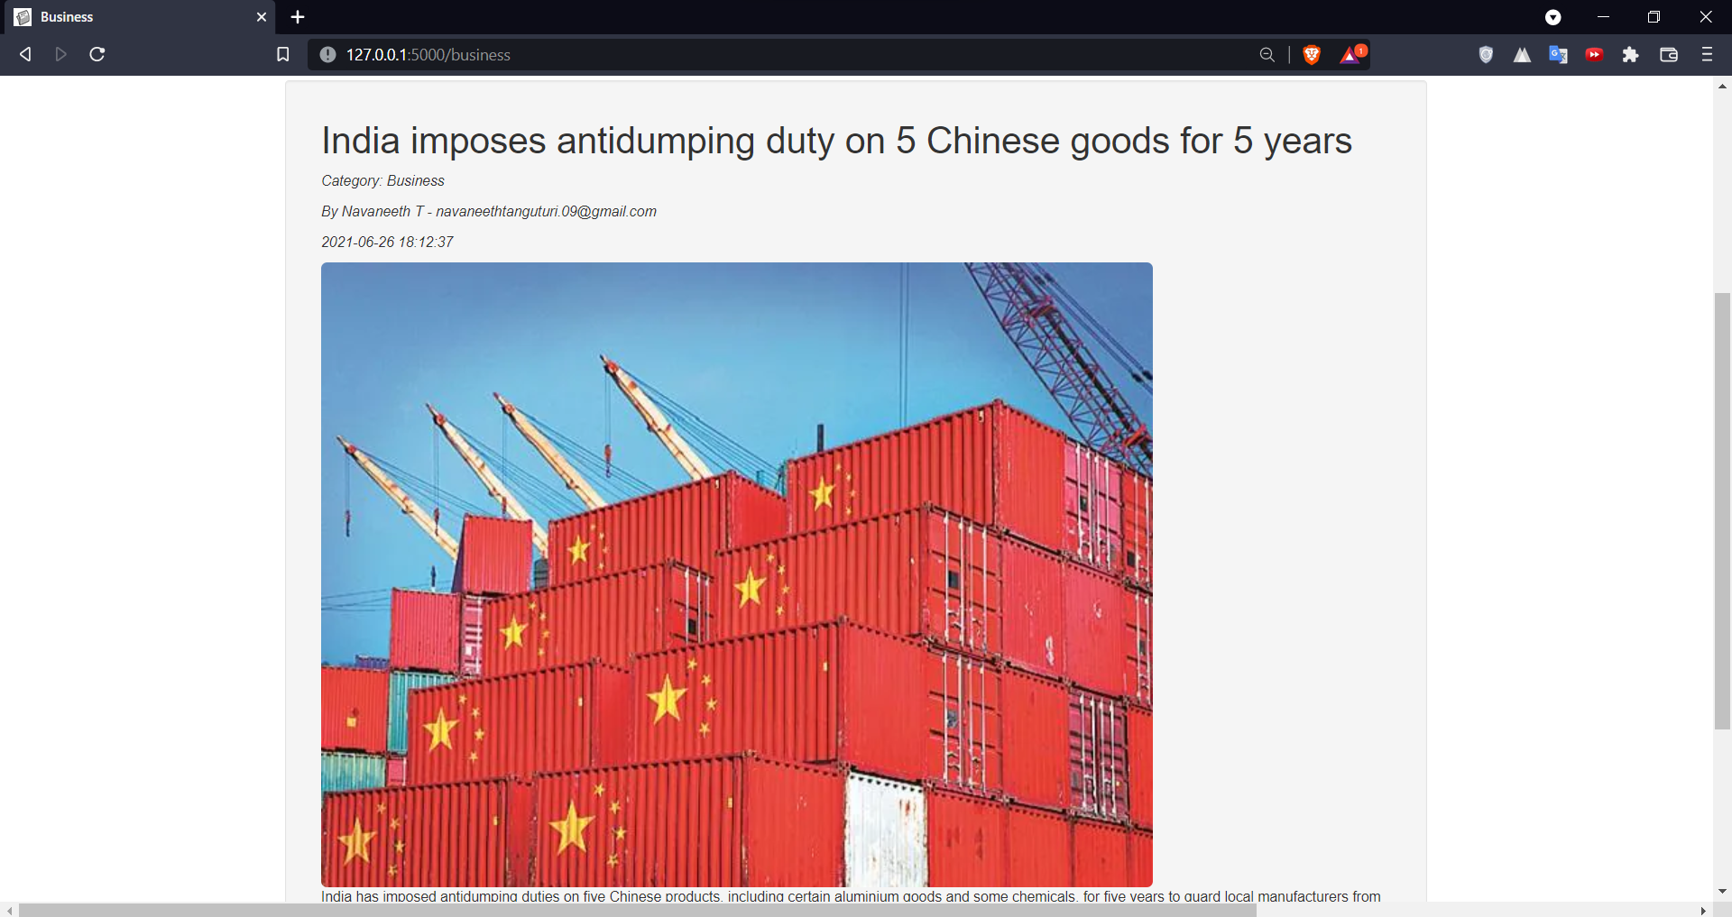

# 5.1.16.3) Viewing news of category ‘Sports’

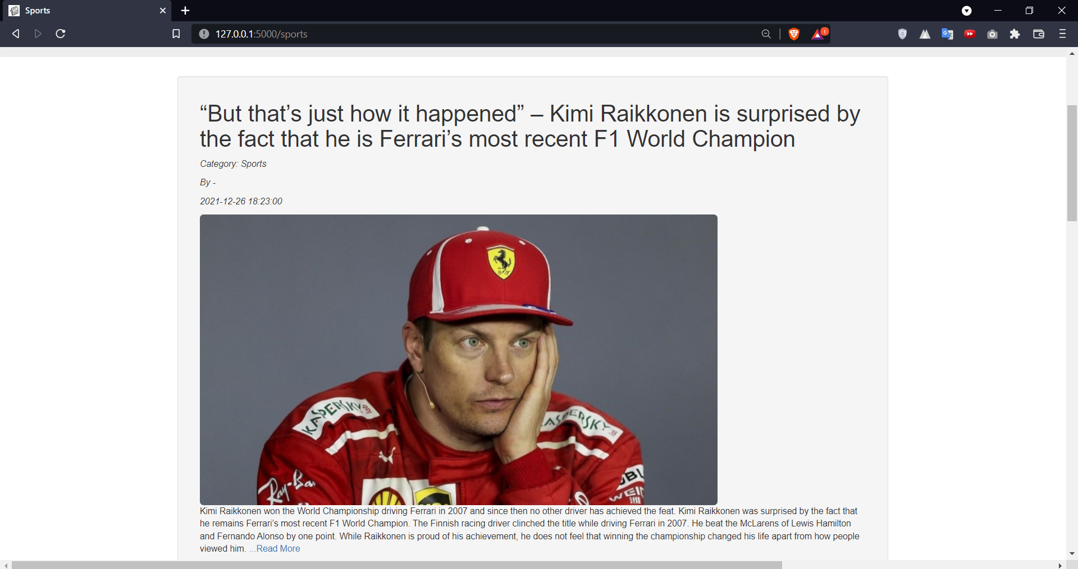

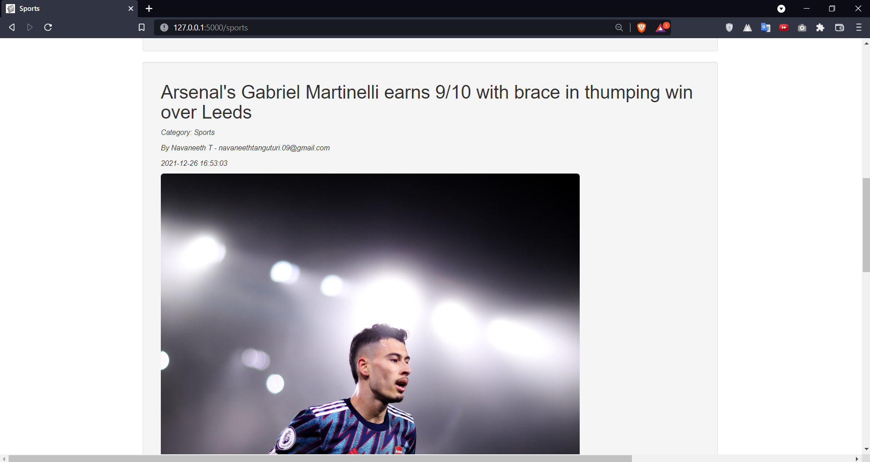

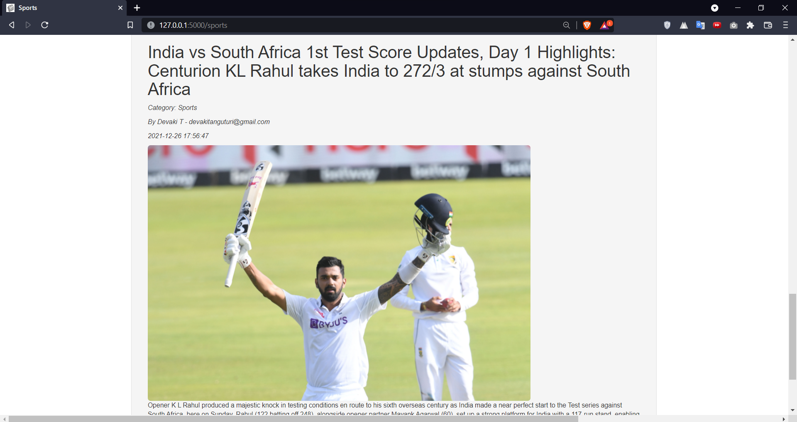

# 5.1.16.4) Viewing news of category ‘Film’

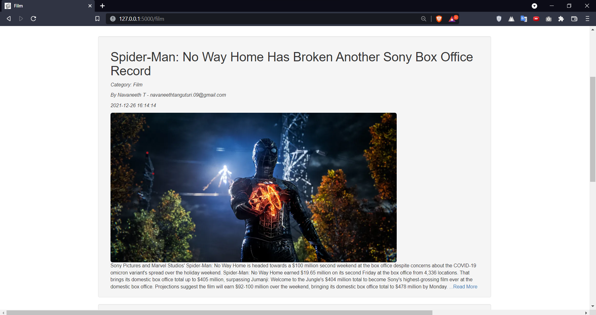

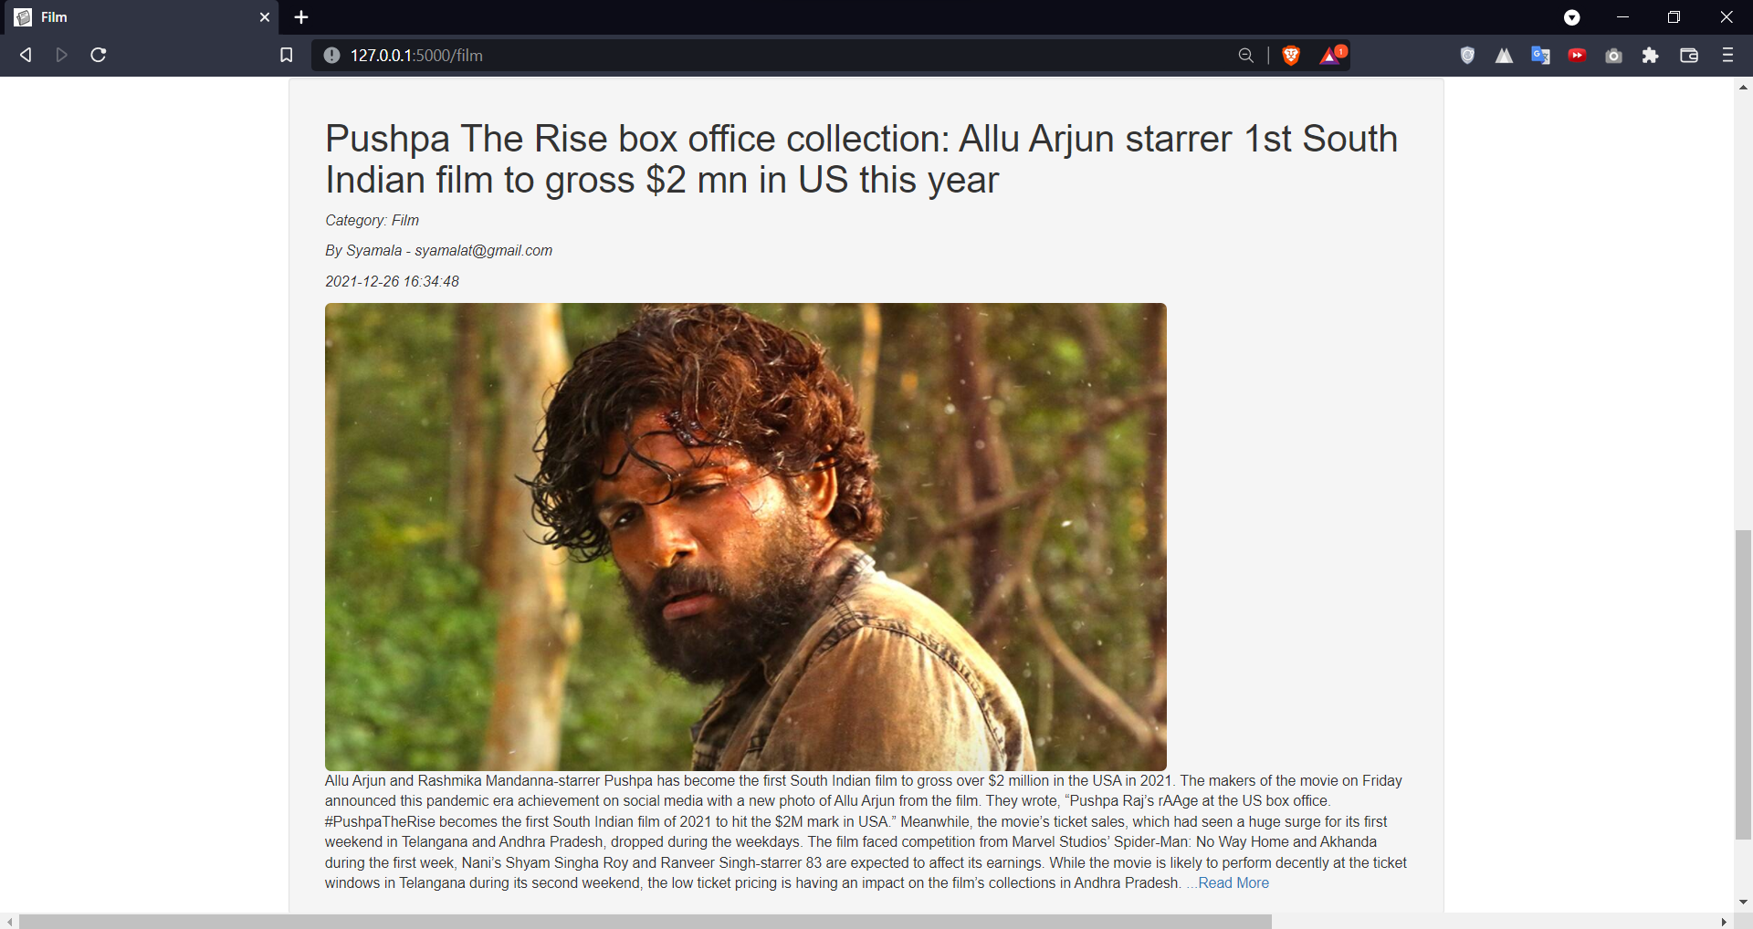

# 5.1.16.5) Viewing news of category ‘Tech’

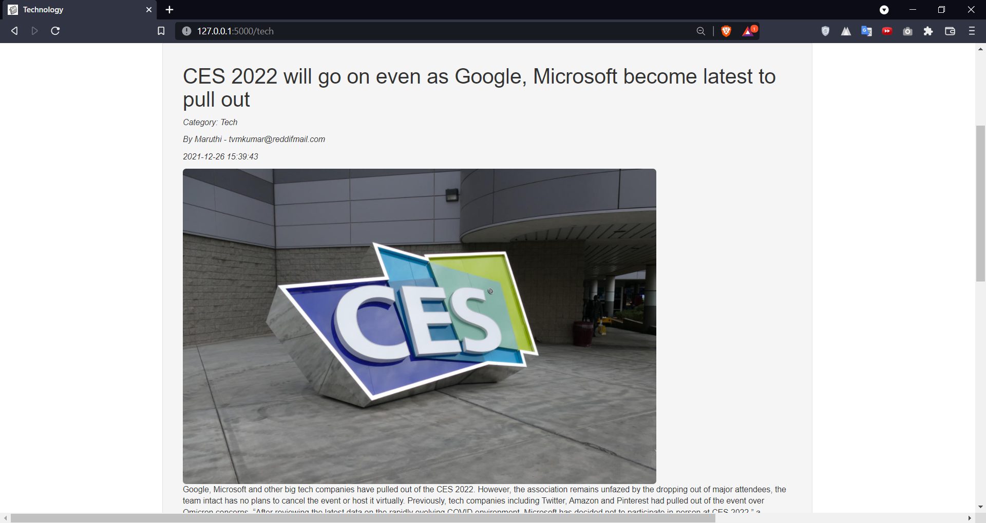

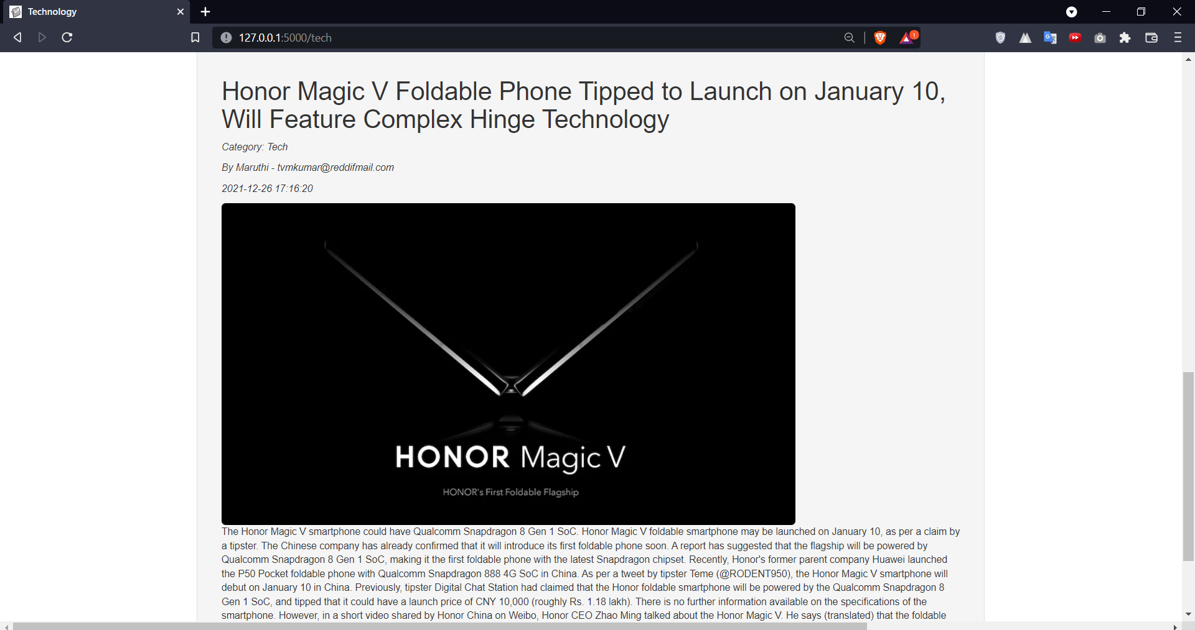

# 5.1.16.6) Viewing news of category ‘World’

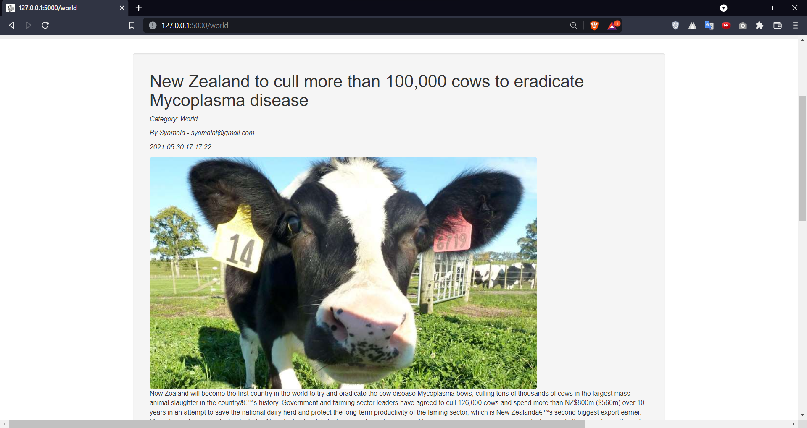

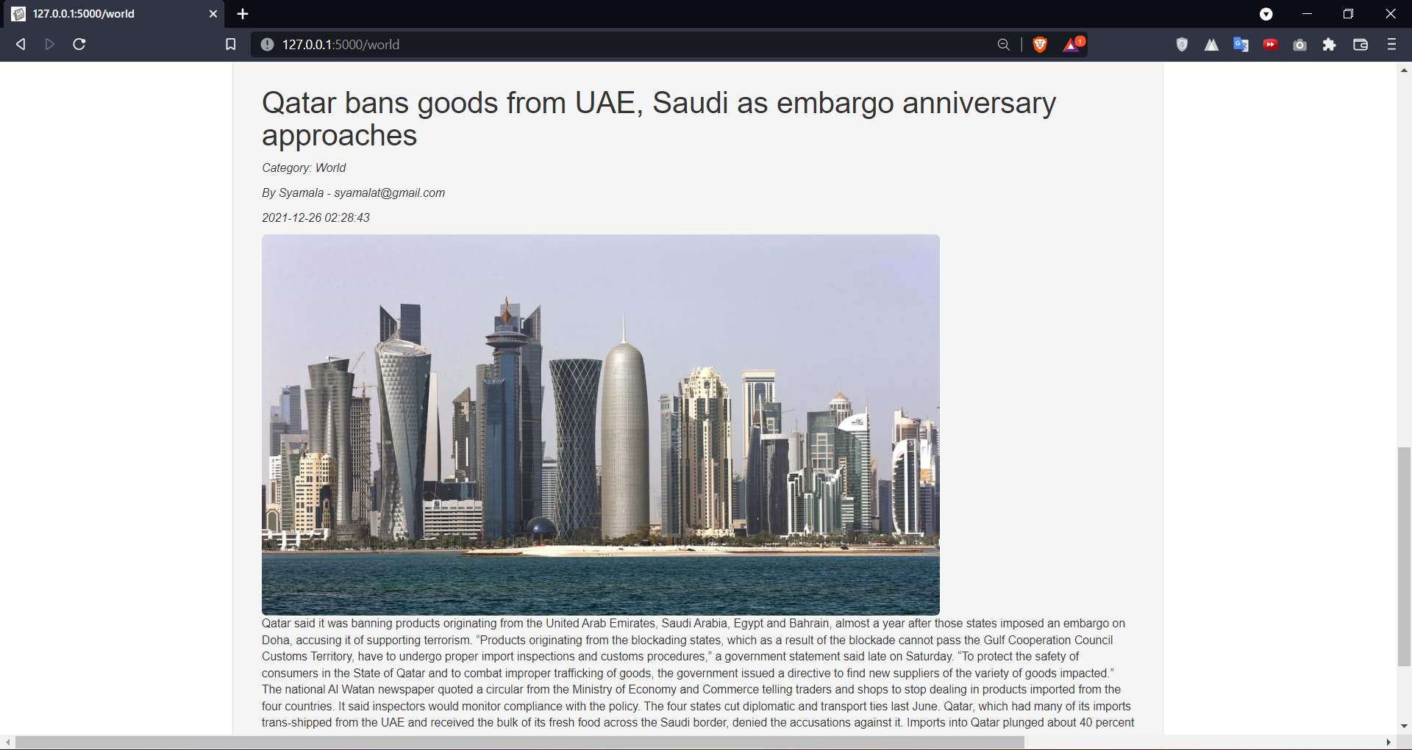

# 5.1.17) Header

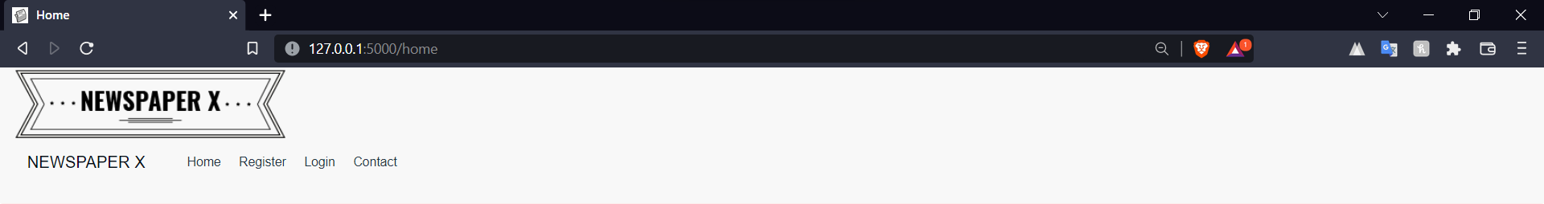

<html>

  <head>

    <title> Newspaper X </title>

    <link rel="shortcut icon" type = "image/x-icon" href = "{{url_for('static', filename='favicon.png')}}">

    <link href="{{url_for('static', filename='css/bootstrap.css')}}" rel="stylesheet" type="text/css">

    <link href="{{url_for('static', filename='css/bootstrap.min.css')}}" rel="stylesheet" type="text/css">

    <link href="{{url_for('static', filename='css/style2.css')}}" rel="stylesheet" type="text/css">

    <link href="https://maxcdn.bootstrapcdn.com/font-awesome/4.4.0/css/font-awesome.min.css" rel="stylesheet"/>

    <link href="https://maxcdn.bootstrapcdn.com/bootstrap/3.3.5/css/bootstrap.min.css" rel="stylesheet"/>

    <script src = "https://ajax.googleapis.com/ajax/libs/jquery/3.1.1/jquery.min.js"> </script>

    <script src = "https://maxcdn.bootstrapcdn.com/bootstrap/3.3.7/js/bootstrap.min.js"> </script>

  </head>

  <body>

    <nav class = "nav navbar-default  foot">

    <div class = "col-md-12"> <img class = "img-responsive" src = "static/image/logo.png" alt = "newspaper-x"> </div>

    <div class = "container-fluid">

      <div class = "nav-header">

        <button type = "button" class = "navbar-toggle" data-toggle = "collapse" data-target = "#NavBar" >

          <span class = "icon-bar"> </span>

          <span class = "icon-bar"> </span>

          <span class = "icon-bar"> </span>

        </button>

        <a class = "navbar-brand" href = "#" style = "color: #040c13"> NEWSPAPER X </a>

      </div>

      <div class = "collapse navbar-collapse" id = "NavBar">

        <ul class = "navbar navbar-expand-xl">

          <li class="nav-item" style="list-style-type: none;"> <a class="nav-link" href = "home" style = "color: #273746"> Home </a> </li>

          <li class="nav-item" style="list-style-type: none;"> <a class="nav-link" href = "registration" style = "color: #273746"> Register </a> </li>

          <li class="nav-item" style="list-style-type: none;"> <a class="nav-link" href = "login" style = "color: #273746"> Login </a> </li>

          <li class="nav-item" style="list-style-type: none;"> <a class="nav-link" href = "contact" style = "color: #273746"> Contact </a> </li>

        </ul>

      </div>

      </div>

      </nav>

  </body>

</html>

# 5.1.18) Footer



<footer class=" foot col-md-12 vert-offset-top-1">

  <link href="https://maxcdn.bootstrapcdn.com/font-awesome/4.4.0/css/font-awesome.min.css" rel="stylesheet" />

  <link href="https://maxcdn.bootstrapcdn.com/bootstrap/3.3.5/css/bootstrap.min.css" rel="stylesheet" />

  <script src="https://ajax.googleapis.com/ajax/libs/jquery/3.1.1/jquery.min.js"> </script>

  <script src="https://maxcdn.bootstrapcdn.com/bootstrap/3.3.7/js/bootstrap.min.js"> </script>

  <div class="container foot">

    <div class="col-md-12">

      <div class="col-md-offset-5 col-md-12 vert-offset-top-0">

        <span class="txt">

          <p class="lead" style="font-size: 18px"> Contact Us </p>

        </span>

      </div>

      <div class="col-md-offset-3">

        <ul class="navbar navbar-expand-xl">

          <li class="nav-item px-3" style="display: inline; font-size: 17px"> <a style="color: #020a11" href="#"> <b

                class="fa fa-facebook"> Facebook </b> </a> </li>

          <li class="nav-item px-3" style="display: inline; font-size: 17px"> <a style="color: #273746" href="#"> <b

                class="fa fa-twitter"> Twitter</b> </a> </li>

          <li class="nav-item px-3" style="display: inline; font-size: 17px"> <a style="color: #273746" href="#"> <b

                class="fa fa-instagram"> Instagram</b> </a> </li>

          <li class="nav-item px-3" style="display: inline; font-size: 17px"> <a style="color: #273746" href="#"> <b

                class="fa fa-linkedin"> LinkedIn </b> </a> </li>

          <li class="nav-item px-3" style="display: inline; font-size: 17px"> <a style="color: #273746" href="#"> <b

                class="fa fa-reddit"> Reddit </b> </a> </li>

        </ul>

      </div>

    </div>

    <div class="col-md-12">

      <div class="col-md-offset-10 col-md-12 vert-offset-top-1">

        <span class="txt">

          <p class="lead" style="font-size: 17px"> © Newspaper X 2021 </p>

        </span>

      </div>

    </div>

  </div>

</footer>

# 5.2) Backend: Flask

# 5.2.1) app.py

import sqlite3 as sql

import os

from flask import Flask, render_template, request, session, flash

from werkzeug.utils import redirect, secure_filename

from spacy.lang.en import English

import numpy as np

from Summarizer1 import summarize

from Translator import Translator

from newsapi import NewsApiClient

from WebScraper import WebScraper

import pyttsx3

from SentimentAnalysis import isOffensive

newsapi = NewsApiClient(api_key='d9dd88d517c24c7690274e6a34457842')

sources = newsapi.get_sources()

app = Flask(__name__)

app.secret_key = '3d6f45a5fc12445dbac2f59c3b6c7cb1'

app.config['UPLOAD_FOLDER'] = "static/image"

@app.route("/")

def start():

return redirect('/home')

@app.route("/home")

def home():

return render_template('homepage.html')

@app.route("/login")

def login():

return render_template('login.html')

@app.route("/authenticate", methods=['GET', 'POST'])

def authenticate():

con = sql.connect(r'''D:\NewsPortal_DB\sqlite\newspaperx.db''')

cur = con.cursor()

email = request.form['email']

password = request.form['password']

query = f"select uid, name, email, password, blocked from userdetail where email = '{email}' and password = '{password}';"

rows = cur.execute(query)

rows = rows.fetchall()

con.commit()

con.close()

if len(rows) == 1 and rows[0][-1] != 1:

session['uid'] = rows[0][0]

session['user'] = rows[0][1]

session['email'] = rows[0][2]

session['password'] = rows[0][3]

return redirect('/profile')

elif len(rows) == 1 and rows[0][-1] == 1:

flash("You are blocked!")

return redirect('/login')

else:

flash("Invalid Login Credentials")

return redirect('/login')

@app.route("/registration", methods=['GET', 'POST'])

def registration():

return render_template('registration.html')

@app.route("/contact")

def contact():

return render_template('contact.html')

@app.route("/register", methods=['POST'])

def register():

con = sql.connect(r'''D:\NewsPortal_DB\sqlite\newspaperx.db''')

cur = con.cursor()

verified = 0

image = 'static/image/default.jpg'

rid = 0

email = request.form['e']

password = request.form['p']

name = request.form['n']

mobile = request.form['m']

address = request.form['address']

cur.execute("insert into userdetail (Name, Mobile, Email, Password, Image, Verified, RID, Address, blocked) VALUES (?, ?, ?, ?, ?, ?, ?, ?, ?)",(name, mobile, email, password, image, verified, rid, address, 0))

con.commit()

con.close()

return redirect('/login')

@app.route('/profile', methods = ['GET', 'POST'])

def profile():

if request.method == "POST":

if 'upload' in request.form.keys():

con = sql.connect(r'''D:\NewsPortal_DB\sqlite\newspaperx.db''')

cur = con.cursor()

uid = session['uid']

if 'image' in request.files:

image = request.files['image']

if(image.filename != ""):

filename = secure_filename(image.filename)

image.save(os.path.join(app.config['UPLOAD_FOLDER'], filename))

filename = app.config['UPLOAD_FOLDER'] + '/' + filename

query = f"update userdetail set image = '{filename}' where uid = '{uid}';"

cur.execute(query)

con.commit()

con.close()

else:

flash("Upload an image first!")

elif 'edit' in request.form.keys():

return redirect('/edit')

con = sql.connect(r'''D:\NewsPortal_DB\sqlite\newspaperx.db''')

cur = con.cursor()

uid = session['uid']

query = f"select * from userdetail where uid = '{uid}';"

rows = cur.execute(query)

rows = rows.fetchall()

uid, name, mobile, email, password, image, verified, rid, address = rows[0][0], rows[0][1], rows[0][2], rows[0][3], rows[0][4], rows[0][5], rows[0][6], rows[0][7], rows[0][8]

query = f"select rname from role where rid = '{rid}';"

rows = cur.execute(query)

rows = rows.fetchall()

rid = rows[0][0]

session['role'] = rid

con.close()

if rid == "Administrator":

user = ["admin"]

return render_template('profile.html', name = name, mobile = mobile, email = email, password = password, image = image, verified = verified, role = rid, address = address, user = user)

elif rid == "Editor":

user = ["editor"]

return render_template('profile.html', name = name, mobile = mobile, email = email, password = password, image = image, verified = verified, role = rid, address = address, user = user)

else:

user = ["user"]

return render_template('profile.html', name = name, mobile = mobile, email = email, password = password, image = image, verified = verified, role = rid, address = address, user = user)

@app.route('/logout')

def logout():

session.clear()

return redirect('/home')

@app.route('/edit', methods = ['POST', 'GET'])

def edit():

uid = session['uid']

con = sql.connect(r'''D:\NewsPortal_DB\sqlite\newspaperx.db''')

cur = con.cursor()

uid = session['uid']

query = f"select * from userdetail where uid = '{uid}';"

rows = cur.execute(query)

rows = rows.fetchall()

uid, name, mobile, email, password, image, verified, rid, address = rows[0][0], rows[0][1], rows[0][2], rows[0][3], rows[0][4], rows[0][5], rows[0][6], rows[0][7], rows[0][8]

if request.method == 'POST':

name = request.form['n']

email = request.form['e']

password = request.form['p']

address = request.form['a']

query = f"update userdetail set name = '{name}', email = '{email}', password = '{password}', address = '{address}' where uid = '{uid}';"

cur.execute(query)

con.commit()

con.close()

return redirect('/profile')

con.close()

return render_template('edit.html', name = name, email = email, password = password, address = address, mobile = mobile)

@app.route('/sports', methods = ['GET', 'POST'])

def sports():

category = 'Sports'

con = sql.connect(r'''D:\NewsPortal_DB\sqlite\newspaperx.db''')

cur = con.cursor()

query = f"select heading, category, image, descript, date, uid, aid from articles where category = '{category}' ORDER BY date DESC;"

rows = cur.execute(query)

rows = rows.fetchall()

for i in range(len(rows)):

query = f"select name,email from userdetail where uid = '{rows[i][5]}';"

name = cur.execute(query)

name = name.fetchall()

if name:

rows[i] = list(rows[i])

rows[i][5] = name[0]

rows[i] = tuple(rows[i])

if session['role'] == "Administrator":

user = ["admin"]

return render_template('news.html', news = 'Sports', posts=rows, user = user)

elif session['role'] == "Editor":

user = ["editor"]

return render_template('news.html', news = 'Sports', posts=rows, user = user)

else:

user = ["user"]

return render_template('news.html', news = 'Sports', posts=rows, user = user)

@app.route('/politics', methods = ['GET', 'POST'])

def politics():

category = 'Politics'

con = sql.connect(r'''D:\NewsPortal_DB\sqlite\newspaperx.db''')

cur = con.cursor()

query = f"select heading, category, image, descript, date, uid, aid from articles where category = '{category}' ORDER BY date DESC;"

rows = cur.execute(query)

rows = rows.fetchall()

for i in range(len(rows)):

query = f"select name,email from userdetail where uid = '{rows[i][5]}';"

name = cur.execute(query)

name = name.fetchall()

if name:

rows[i] = list(rows[i])

rows[i][5] = name[0]

rows[i] = tuple(rows[i])

if session['role'] == "Administrator":

user = ["admin"]

return render_template('news.html', news = 'Politics', posts=rows, user = user)

elif session['role'] == "Editor":

user = ["editor"]

return render_template('news.html', news = 'Politics', posts=rows, user = user)

else:

user = ["user"]

return render_template('news.html', news = 'Politics', posts=rows, user = user)

@app.route('/tech', methods = ['GET', 'POST'])

def tech():

category = 'Tech'

con = sql.connect(r'''D:\NewsPortal_DB\sqlite\newspaperx.db''')

cur = con.cursor()

query = f"select heading, category, image, descript, date, uid, aid from articles where category = '{category}' ORDER BY date DESC;"

rows = cur.execute(query)

rows = rows.fetchall()

for i in range(len(rows)):

query = f"select name,email from userdetail where uid = '{rows[i][5]}';"

name = cur.execute(query)

name = name.fetchall()

if name:

rows[i] = list(rows[i])

rows[i][5] = name[0]

rows[i] = tuple(rows[i])

if session['role'] == "Administrator":

user = ["admin"]

return render_template('news.html', news = 'Technology', posts=rows, user = user)

elif session['role'] == "Editor":

user = ["editor"]

return render_template('news.html', news = 'Technology', posts=rows, user = user)

else:

user = ["user"]

return render_template('news.html', news = 'Technology', posts=rows, user = user)

@app.route('/film', methods = ['GET', 'POST'])

def film():

category = 'Film'

con = sql.connect(r'''D:\NewsPortal_DB\sqlite\newspaperx.db''')

cur = con.cursor()

query = f"select heading, category, image, descript, date, uid, aid from articles where category = '{category}' ORDER BY date DESC;"

rows = cur.execute(query)

rows = rows.fetchall()

for i in range(len(rows)):

query = f"select name,email from userdetail where uid = '{rows[i][5]}';"

name = cur.execute(query)

name = name.fetchall()

if name:

rows[i] = list(rows[i])

rows[i][5] = name[0]

rows[i] = tuple(rows[i])

if session['role'] == "Administrator":

user = ["admin"]

return render_template('news.html', news = 'Film', posts=rows, user = user)

elif session['role'] == "Editor":

user = ["editor"]

return render_template('news.html', news = 'Film', posts=rows, user = user)

else:

user = ["user"]

return render_template('news.html', news = 'Film', posts=rows, user = user)

@app.route('/world', methods = ['GET', 'POST'])

def world():

category = 'World'

con = sql.connect(r'''D:\NewsPortal_DB\sqlite\newspaperx.db''')

cur = con.cursor()

query = f"select heading, category, image, descript, date, uid, aid from articles where category = '{category}' ORDER BY date DESC;"

rows = cur.execute(query)

rows = rows.fetchall()

for i in range(len(rows)):

query = f"select name,email from userdetail where uid = '{rows[i][5]}';"

name = cur.execute(query)

name = name.fetchall()

if name:

rows[i] = list(rows[i])

rows[i][5] = name[0]

rows[i] = tuple(rows[i])

if session['role'] == "Administrator":

user = ["admin"]

return render_template('news.html', news = 'World', posts=rows, user = user)

elif session['role'] == "Editor":

user = ["editor"]

return render_template('news.html', news = 'World', posts=rows, user = user)

else:

user = ["user"]

return render_template('news.html', news = 'World', posts=rows, user = user)

@app.route('/business', methods = ['GET', 'POST'])

def business():

category = 'Business'

con = sql.connect(r'''D:\NewsPortal_DB\sqlite\newspaperx.db''')

cur = con.cursor()

query = f"select heading, category, image, descript, date, uid, aid from articles where category = '{category}' ORDER BY date DESC;"

rows = cur.execute(query)

rows = rows.fetchall()

for i in range(len(rows)):

query = f"select name,email from userdetail where uid = '{rows[i][5]}';"

name = cur.execute(query)

name = name.fetchall()

if name:

rows[i] = list(rows[i])

rows[i][5] = name[0]

rows[i] = tuple(rows[i])

if session['role'] == "Administrator":

user = ["admin"]

return render_template('news.html', news = 'Business', posts=rows, user = user)

elif session['role'] == "Editor":

user = ["editor"]

return render_template('news.html', news = 'Business', posts=rows, user = user)

else:

user = ["user"]

return render_template('news.html', news = 'Business', posts=rows, user = user)

@app.route("/newpost")

def NewPost():

return render_template('AddNewPost.html')

@app.route("/addnewpost", methods = ['GET', 'POST'])

def AddNewPost():

heading = request.form['head']

category = request.form['cat']

description = request.form['descri']

rating = isOffensive(description)[0]

if rating['label'] == '1 star':

flash('Your post could be found offensive to some readers')

return render_template('AddNewPost.html')

image = request.files['image']

con = sql.connect(r'''D:\NewsPortal_DB\sqlite\newspaperx.db''')

cur = con.cursor()

if(image.filename != ""):

filename = secure_filename(image.filename)

image.save(os.path.join(app.config['UPLOAD_FOLDER'], filename))

filename = app.config['UPLOAD_FOLDER'] + '/' + filename

query = f"select datetime('now', 'localtime');"

date = cur.execute(query)

date = cur.fetchone()

query = f"insert into articles (Heading, Category, Image, Descript, Date, UID) VALUES ('{heading}', '{category}', '{filename}', '{description}', '{date[0]}', '{session['uid']}');"

cur.execute(query)

con.commit()

flash("Post added successfully")

return render_template('AddNewPost.html')

@app.route("/verifiedUsers", methods = ['GET', 'POST'])

def verifiedUsers():

con = sql.connect(r'''D:\NewsPortal_DB\sqlite\newspaperx.db''')

cur = con.cursor()

if request.method == 'POST':

if request.form['submit_button'] == 'block':

checkedList = request.form.getlist('check[]')

for i in checkedList:

query = f"update userdetail set blocked = 1 where uid ='{i}';"

cur.execute(query)

con.commit()

if request.form['submit_button'] == 'unblock':

checkedList = request.form.getlist('check[]')

for i in checkedList:

query = f"update userdetail set blocked = 0 where uid ='{i}';"

cur.execute(query)

con.commit()

if request.form['submit_button'] == 'mkeditor':

checkedList = request.form.getlist('check[]')

for i in checkedList:

query = f"update userdetail set rid = 2 where uid = '{i}';"

cur.execute(query)

con.commit()

if request.form['submit_button'] == 'mkuser':

checkedList = request.form.getlist('check[]')

for i in checkedList:

query = f"update userdetail set rid = 1 where uid = '{i}';"

cur.execute(query)

con.commit()

if request.form['submit_button'] == 'rmver':

checkedList = request.form.getlist('check[]')

for i in checkedList:

query = f"update userdetail set verified = 0 where uid = '{i}';"

cur.execute(query)

con.commit()

con = sql.connect(r'''D:\NewsPortal_DB\sqlite\newspaperx.db''')

cur = con.cursor()

query = f"select uid, name, email, password from userdetail where verified = 1;"

rows = cur.execute(query)

rows = rows.fetchall()

query = f"select rid from userdetail where verified = 1;"

rid = cur.execute(query)

rid = rid.fetchall()

for i in range(len(rid)):

rows[i] = list(rows[i])

role = cur.execute(f"select rname from role where rid = '{rid[i][0]}'")

role = role.fetchone()

rows[i].append(role[0])

rows[i] = tuple(rows[i])

con.close()

return render_template('verifiedUsers.html', rows = rows)

@app.route("/non-verifiedUsers", methods = ['GET', 'POST'])

def nonVerifiedUsers():

con = sql.connect(r'''D:\NewsPortal_DB\sqlite\newspaperx.db''')

cur = con.cursor()

if request.method == 'POST':

if request.form['submit_button'] == 'block':

checkedList = request.form.getlist('check[]')

for i in checkedList:

query = f"update userdetail set blocked = 1 where uid ='{i}';"

cur.execute(query)

con.commit()

if request.form['submit_button'] == 'unblock':

checkedList = request.form.getlist('check[]')

for i in checkedList:

query = f"update userdetail set blocked = 0 where uid ='{i}';"

cur.execute(query)

con.commit()

if request.form['submit_button'] == 'mkeditor':

checkedList = request.form.getlist('check[]')

for i in checkedList:

query = f"update userdetail set rid = 2 where uid = '{i}';"

cur.execute(query)

con.commit()

if request.form['submit_button'] == 'mkuser':

checkedList = request.form.getlist('check[]')

for i in checkedList:

query = f"update userdetail set rid = 1 where uid = '{i}';"

cur.execute(query)

con.commit()

if request.form['submit_button'] == 'rmver':

checkedList = request.form.getlist('check[]')

for i in checkedList:

query = f"update userdetail set verified = 1 where uid = '{i}';"

cur.execute(query)

con.commit()

con = sql.connect(r'''D:\NewsPortal_DB\sqlite\newspaperx.db''')

cur = con.cursor()

query = f"select uid, name, email, password from userdetail where verified = 0;"

rows = cur.execute(query)

rows = rows.fetchall()

query = f"select rid from userdetail where verified = 0;"

rid = cur.execute(query)

rid = rid.fetchall()

for i in range(len(rid)):

rows[i] = list(rows[i])

role = cur.execute(f"select rname from role where rid = '{rid[i][0]}'")

role = role.fetchone()

rows[i].append(role[0])

rows[i] = tuple(rows[i])

con.close()

return render_template('nonVerifiedUsers.html', rows = rows)

@app.route("/verifiedArticles", methods = ['GET', 'POST'])

def verifiedArticles():

con = sql.connect(r'''D:\NewsPortal_DB\sqlite\newspaperx.db''')

cur = con.cursor()

if request.method == 'POST':

if request.form['delete'] == 'delete':

checkedList = request.form.getlist('check[]')

for i in checkedList:

query = f"delete from articles where aid = '{i}';"

cur.execute(query)

con.commit()

query = f"select heading, image, descript, date, uid, aid from articles where uid in (select uid from userdetail where verified = 1);"

rows = cur.execute(query)

rows = rows.fetchall()

for i in range(len(rows)):

rows[i] = list(rows[i])

name = cur.execute(f"select name from userdetail where uid = '{rows[i][4]}'").fetchone()

rows[i][4] = name[0]

nlp = English()

nlp.add_pipe('sentencizer')

rows[i][2] = summarize(text = rows[i][2], per=0.5)

rows[i] = tuple(rows[i])

con.close()

return render_template('verifiedArticles.html', rows = rows)

@app.route("/non-verifiedArticles", methods = ['GET', 'POST'])

def nonVerifiedArticles():

con = sql.connect(r'''D:\NewsPortal_DB\sqlite\newspaperx.db''')

cur = con.cursor()

if request.method == 'POST':

if request.form['delete'] == 'delete':

checkedList = request.form.getlist('check[]')

for i in checkedList:

query = f"delete from articles where aid = '{i}';"

cur.execute(query)

con.commit()

query = f"select heading, image, descript, date, uid, aid from articles where uid in (select uid from userdetail where verified = 0);"

rows = cur.execute(query)

rows = rows.fetchall()

for i in range(len(rows)):

rows[i] = list(rows[i])

name = cur.execute(f"select name from userdetail where uid = '{rows[i][4]}'").fetchone()

rows[i][4] = name[0]

nlp = English()

nlp.add_pipe('sentencizer')

rows[i][2] = summarize(text = rows[i][2], per=0.5)

rows[i] = tuple(rows[i])

con.close()

return render_template('verifiedArticles.html', rows = rows)

@app.route('/ReadPost<aid>', methods = ['GET', 'POST'])

def ReadPost(aid):

con = sql.connect(r'''D:\NewsPortal_DB\sqlite\newspaperx.db''')

cur = con.cursor()

query = f"select heading, category, image, descript, date, uid from articles where aid = '{aid}' ORDER BY date DESC;"

rows = cur.execute(query)

rows = rows.fetchall()

query = f"select name,email from userdetail where uid = '{rows[0][5]}';"

name = cur.execute(query)

name = name.fetchall()

if name:

rows[0] = list(rows[0])

rows[0][5] = name[0]

rows[0] = tuple(rows[0])

if request.method == "POST":

if request.form['submit_button'] == 'Summarize':

rows[0] = list(rows[0])

rows[0][3] = summarize(text = rows[0][3], per=0.5)

rows[0] = tuple(rows[0])

elif request.form['submit_button'] == 'Translate':

rows[0] = list(rows[0])

rows[0][3] = Translator(rows[0][3])

rows[0] = tuple(rows[0])

elif request.form['submit_button'] == 'Audio':

description = rows[0][3]

pyobj = pyttsx3.init()

pyobj.say(description)

pyobj.runAndWait()

return render_template('ReadPost.html', heading = rows[0][0], category = rows[0][1], name = rows[0][5][0], email = rows[0][5][1], date = rows[0][4], source = rows[0][2], description = rows[0][3], aid = aid)

@app.route('/news', methods = ['GET', 'POST'])

def gnews():

if request.method == 'POST':

query = request.form.get('searchbar')

from_date = request.form.get('from')

to_date = request.form.get('to')

top_headlines = ""

if(from_date == "" or to_date == ""):

top_headlines = newsapi.get_everything(q=query,language="en")

else:

top_headlines = newsapi.get_everything(q=query,language="en", from_param=from_date, to=to_date)

articles = top_headlines['articles']

return render_template('gnews.html', articles = articles)

else:

return render_template('gnews.html')

@app.route('/readURL', methods = ['GET', 'POST'])

def webscrape():

if request.method == 'POST':

name = request.form['author']

heading = request.form['title']

URL = request.form['URL']

date = request.form['date']

content = request.form['content']

source = request.form['source']

i = -7

chars = ""

while content[i] != '+':

chars += content[i]

i -= 1

chars = int(chars[::-1])

starting = content[:25]

description = WebScraper(URL)

while not description.startswith(starting):

description = description[1:]

description = description[:chars+18]

return render_template('ReadPostURL.html', heading = heading, name = name, date = date, description = description, source = source, sourceURL = URL)

@app.route('/ReadPostURL', methods = ['GET', 'POST'])

def readPostURL():

if request.method == 'POST':

description = request.form.get('description')

heading = request.form.get('heading')

name = request.form.get('name')

date = request.form.get('date')

source = request.form.get('source')

if request.form['submit_button'] == 'Translate':

language = request.form.get('language')

print(language)

languages = {

'Hindi' : 'hi',

'Telugu' : 'te',

'Tamil' : 'ta',

'Kannada' : 'kn',

}

language = languages[language]

description = Translator(description, language)

elif request.form['submit_button'] == 'Audio':

description = request.form.get('description')

pyobj = pyttsx3.init()

pyobj.say(description)

pyobj.runAndWait()

return render_template('ReadPostURL.html', heading = heading, name = name, date = date, description = description, source = source)

@app.route('/viewposts', methods = ['GET', 'POST'])

def viewposts():

con = sql.connect(r'''D:\NewsPortal_DB\sqlite\newspaperx.db''')

cur = con.cursor()

if request.method == 'POST':

aid = request.form.get('aid')

query = f"delete from articles where aid = '{aid}'"

cur.execute(query)

con.commit()

uid = session['uid']

query = f"select heading, category, image, descript, date, uid, aid from articles where uid = '{uid}' ORDER BY date DESC;"

rows = cur.execute(query)

rows = rows.fetchall()

for i in range(len(rows)):

query = f"select name,email from userdetail where uid = '{rows[i][5]}';"

name = cur.execute(query)

name = name.fetchall()

if name:

rows[i] = list(rows[i])

rows[i][5] = name[0]

rows[i] = tuple(rows[i])

user = ["editor"]

return render_template('ViewMyPosts.html', news = 'Business', posts=rows, user = user)

if __name__ == "__main__":

app.run(debug=True)

# 5.2.2) Summarizer.py

Code

import spacy

from spacy.lang.en.stop_words import STOP_WORDS

from string import punctuation

from heapq import nlargest

def summarize(text, per):

    nlp = spacy.load('en_core_web_sm')

    doc= nlp(text)

    tokens=[token.text for token in doc]

    word_frequencies={}

    for word in doc:

        if word.text.lower() not in list(STOP_WORDS):

            if word.text.lower() not in punctuation:

                if word.text not in word_frequencies.keys():

                    word_frequencies[word.text] = 1

                else:

                    word_frequencies[word.text] += 1

    max_frequency=max(word_frequencies.values())

    for word in word_frequencies.keys():

        word_frequencies[word]=word_frequencies[word]/max_frequency

    sentence_tokens= [sent for sent in doc.sents]

    sentence_scores = {}

    for sent in sentence_tokens:

        for word in sent:

            if word.text.lower() in word_frequencies.keys():

                if sent not in sentence_scores.keys():

                    sentence_scores[sent]=word_frequencies[word.text.lower()]

                else:

                    sentence_scores[sent]+=word_frequencies[word.text.lower()]

    select_length=int(len(sentence_tokens)*per)

    summary=nlargest(select_length, sentence_scores,key=sentence_scores.get)

    final_summary=[word.text for word in summary]

    summary=''.join(final_summary)

    return summary

# 5.2.3) SentimentAnalysis.py

from transformers import pipeline

def isOffensive(st):

    seq = pipeline(task="text-classification", model = "nlptown/bert-base-multilingual-uncased-sentiment")

    return  seq(st)

# 5.2.4) Translator.py

from google_trans_new import google_translator

def Translator(text, language):

    translator = google_translator()

    translate_text = translator.translate(text, lang_src='en', lang_tgt=language)

    return translate_text

# 5.2.5) WebScraper.py

import requests

from bs4 import BeautifulSoup

def WebScraper(URL):

    r = requests.get(URL)

    soup = BeautifulSoup(r.text, 'html.parser')

    results = soup.find_all(['h1', 'p'])

    text = [result.text for result in results]

    ARTICLE = ' '.join(text)

    return ARTICLE

# 5.3) Databases

# 5.3.1) ‘newspaperx’ database

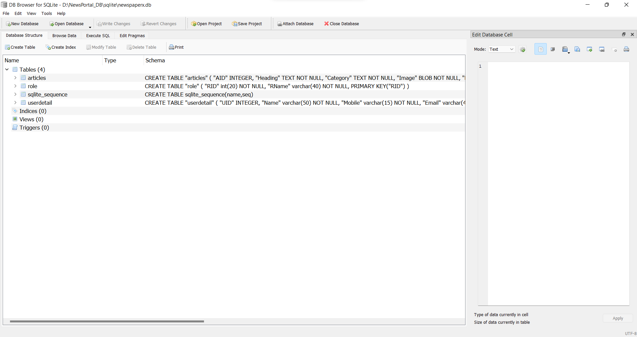

# 5.3.1) ‘role’ table

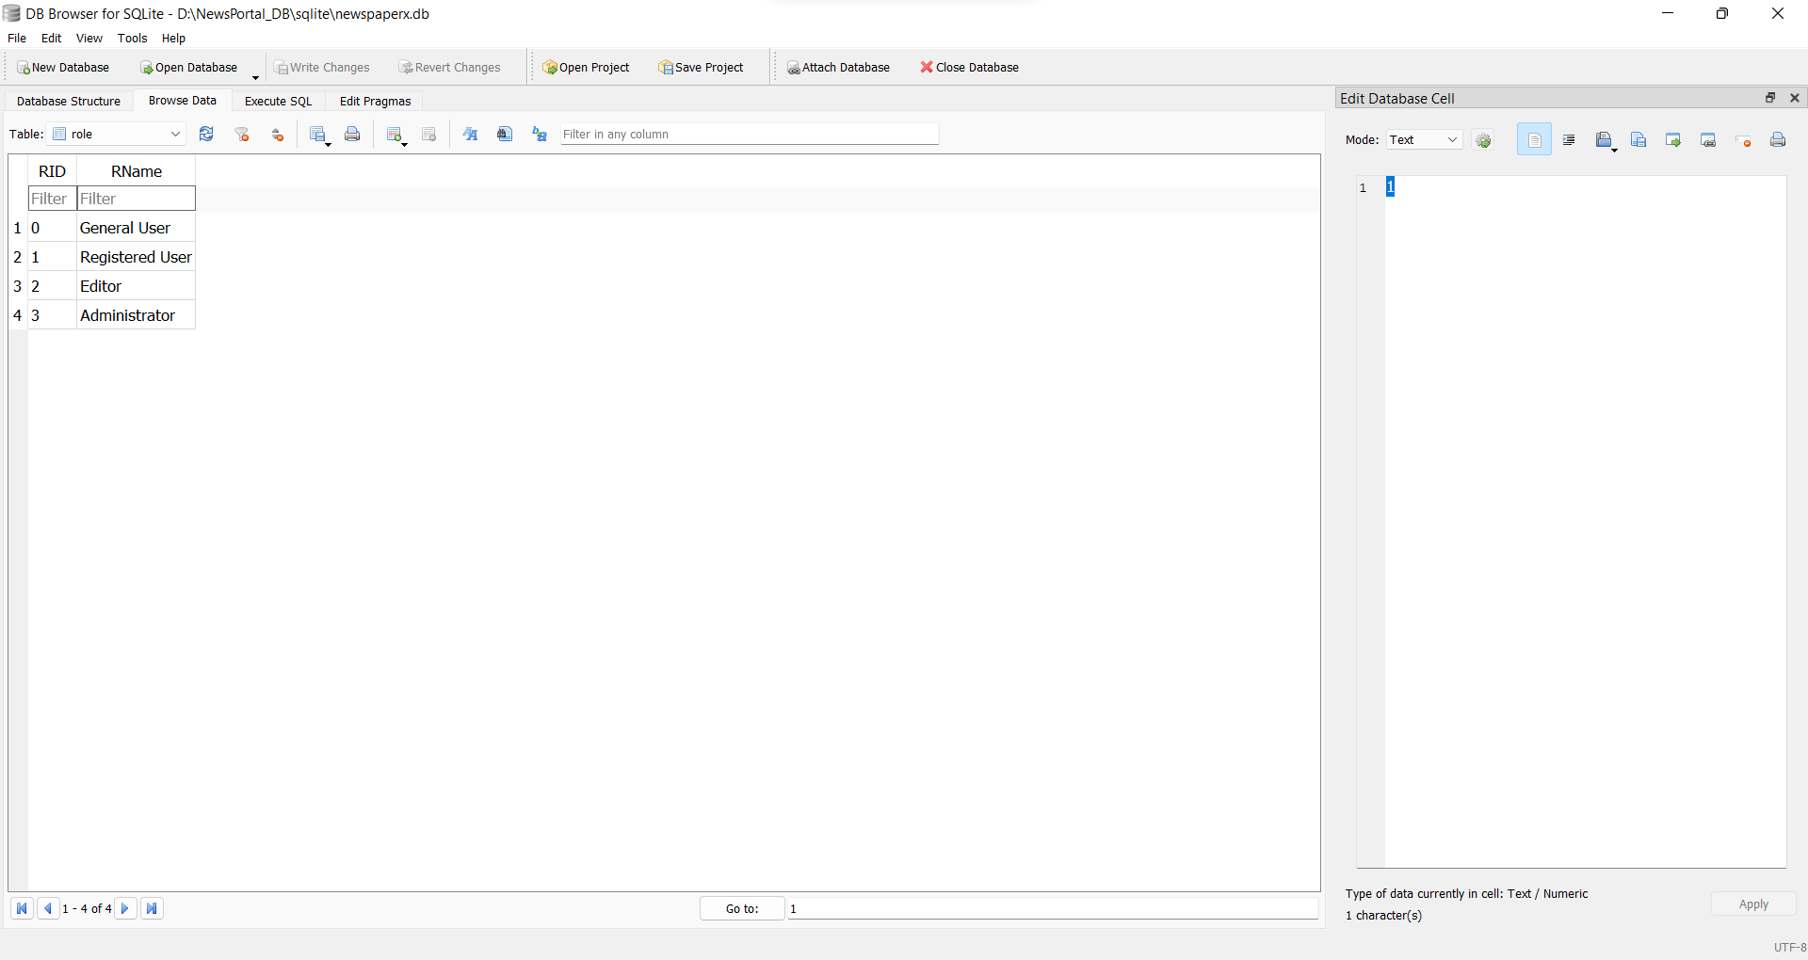

# 5.3.1) ‘articles’ table

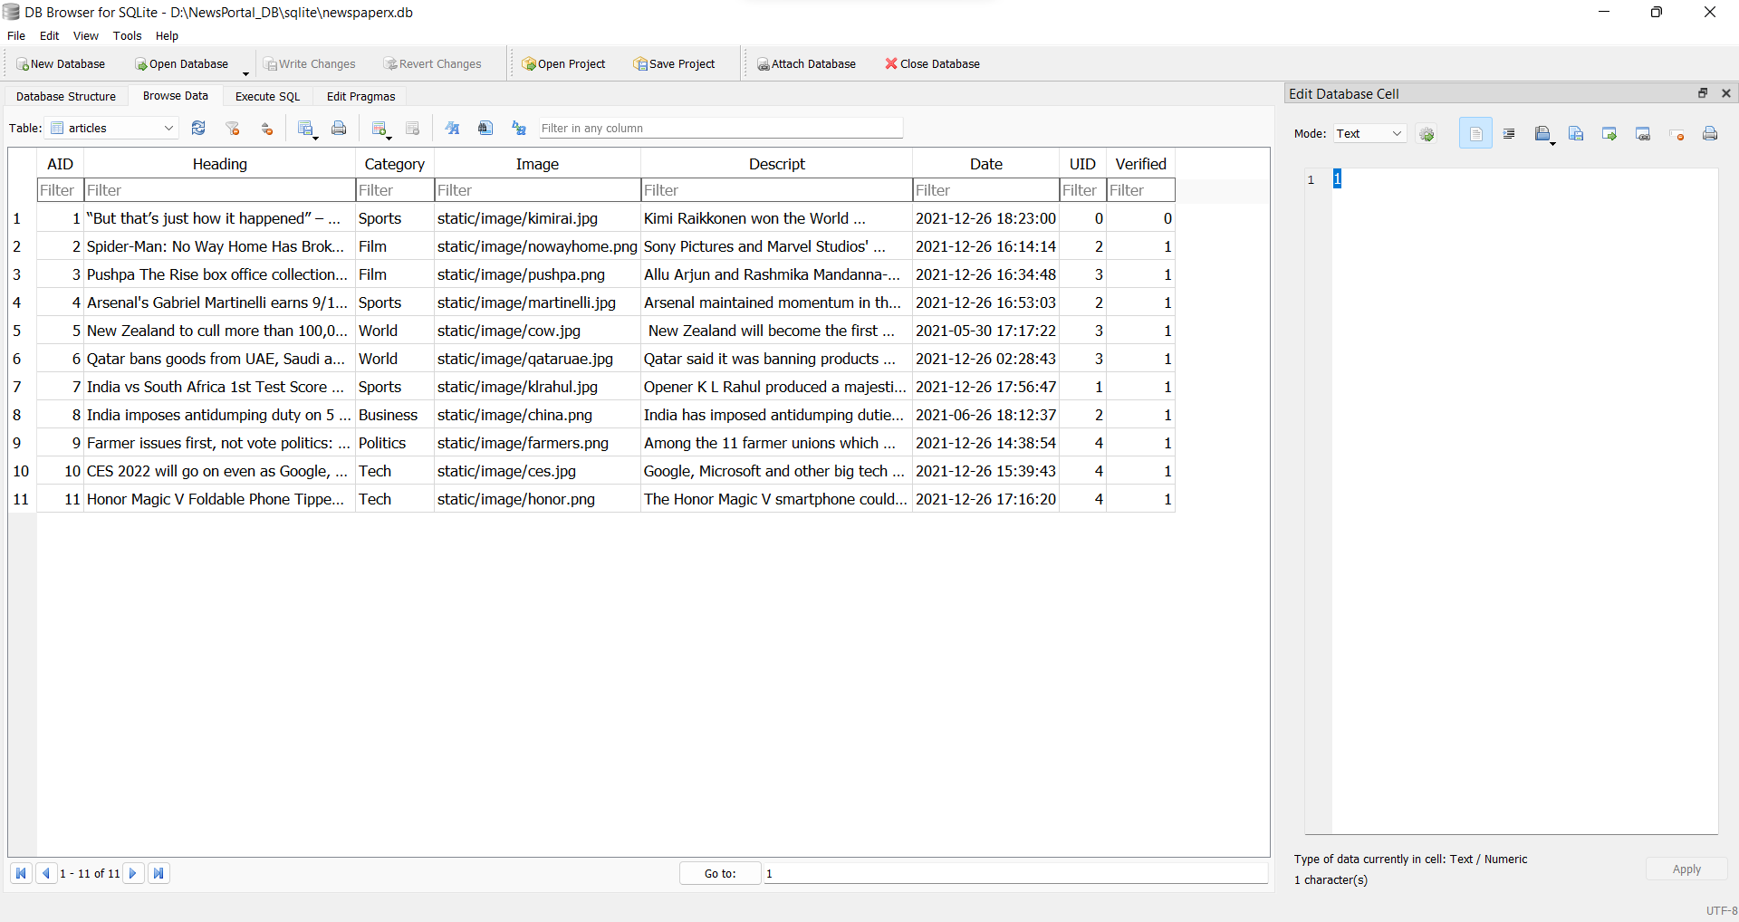

# 5.3.1) ‘userdetail’ table

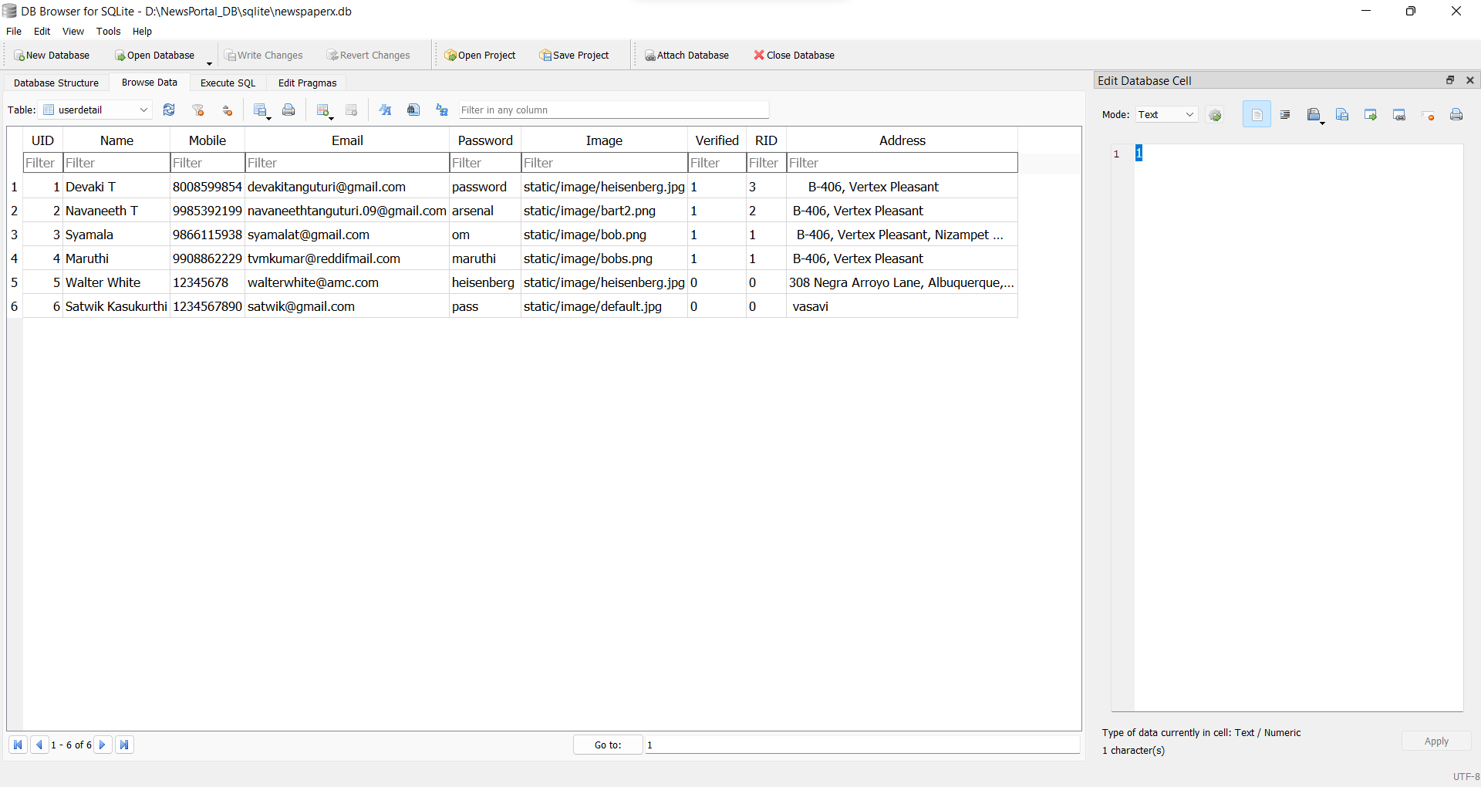

# FUTURE SCOPE

This project has laid a strong foundation and I believe because of this foundation we can further improve the project by adding various other functionalities.

For starters, there could be a possible channel of communication between the editor and the reader to express his thoughts on the article.

Secondly, we can add upvotes and downvotes to each post.

# 7) REFERENCES

* <https://newsapi.org/>
* <https://flask.palletsprojects.com/en/2.1.x/>
* <https://getbootstrap.com/>
* <https://py-googletrans.readthedocs.io/en/latest/>
* <https://spacy.io/api/doc>
* <https://huggingface.co/nlptown/bert-base-multilingual-uncased-sentiment>